CHAPTER **5** | Externalities, Environmental

Policy, and Public Goods

Solutions to End-of-Chapter Exercises

|  |  |
| --- | --- |
| **5.1** | Externalities and Economic Efficiency  Learning Objective: Identify examples of positive and negative externalities and use graphs to show how externalities affect economic efficiency. |
|  |
|  |

Review Questions

**1.1** An externality is a benefit or cost that affects someone who is not directly involved in the production or consumption of a good or service. Examples of positive externalities include (1) the benefits received by a passerby who enjoys a beautiful garden, and (2) the benefits from a college education that go to one’s children, grandchildren, coworkers, or complete strangers. Examples of negative externalities include (1) the noise from a loud party or from a jetliner, and (2) the pollution emitted by a factory.

**1.2** The private cost of producing a good will differ from the social cost when there is an externality. For example, the private cost of producing electricity includes the costs of the fuel and running the power plant, but the social cost includes the private costs plus the costs of the pollution emitted (a negative externality)—which can reduce visibility and cause health problems. The private benefit of consuming a good differs from the social benefit when there is an externality. For example, the private benefit from your college education includes your enjoyment of the experience and the increase in income you’ll receive as a college graduate, but the social benefits include the benefits to third parties (a positive externality), such as your potential coworkers’ improved productivity because you know more, or the gains to people who receive more services from the government because you earn more and pay more taxes.

**1.3** Economic efficiency occurs when the marginal benefit to consumers of the last unit produced is equal to its marginal cost of production and where the sum of consumer surplus and producer surplus is maximized. Externalities generally reduce economic efficiency because buyers and firms ignore the external cost or benefit, which leads firms to either overproduce the good if there is an external cost, or underproduce the good if there is an external benefit.

**1.4** Market failure is the failure of the market to produce the efficient level of output. Externalities, public goods, and common resources all cause market failure (as does monopoly, which will be covered in a later chapter).

**1.5** Externalities generally arise because of incomplete property rights or from the difficulty in enforcing property rights.

Problems and Applications

**1.6** Under these circumstances, consumption of Big Macs causes a small negative externality. These types of externalities also exist on highways, particularly at rush hour, when your decision to drive on the highway causes other motorists to take slightly longer to complete their trips. Governments sometimes deal with traffic externalities by charging higher tolls during peak commuting hours. Governments are unlikely to intervene to relieve congestion in lines at McDonald’s, however. Because the people being inconvenienced by you are also McDonald’s customers, the firm is in the best position to decide how to deal with congestion in its stores.

**1.7** The neighbor’s barking dog serves as a positive externality when it makes you aware of or prevents a dangerous situation like a burglar going into your house. The barking dog serves as a negative externality when it barks constantly and disturbs you.

**1.8** Obtaining human food often leads the bear to seek more human food, which causes the bear to be destroyed or removed from the park. For campers and hikers, the bear seeking human food could lead to the bear mauling or killing a camper or hiker.

**1.9 a.** A positive externality arises from getting the flu shot because people in addition to the person getting the shot receive benefits.

**b.** Because a positive externality arises from getting a flu shot, the efficient quantity (*Q*efficient) and price (*P*efficient) are found by locating where marginal social benefit (*D*2) and supply intersect. The gray shaded area represents the deadweight loss.

**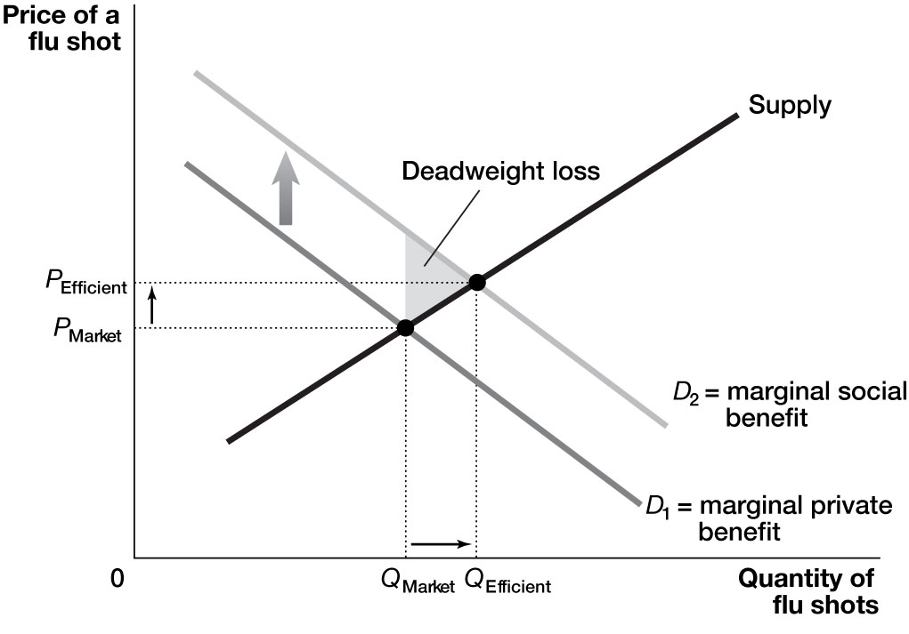**

**1.10** Driving cars increases traffic congestion and air pollution. Bikers and bike lanes could decrease both congestion and air pollution. Whether a city should install more bike lanes depends partly on how many additional people would bike rather than drive.

**1.11** The efficient amount of alcohol consumption is *Q*2, but because the negative externality is ignored, actual consumption is *Q*1. The deadweight loss is area *A*.

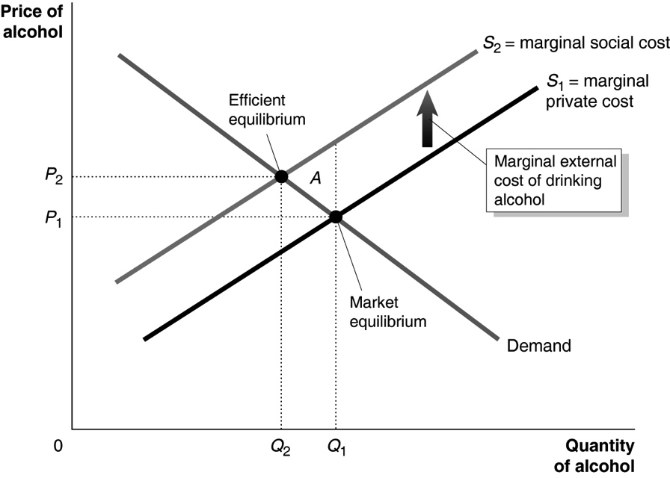

**1.12** **a.** A positive externality arises from studying.

**b.** Tom’s demand for studying is *D*2, the marginal social benefit curve, which adds together his marginal private benefit and the marginal external benefit to his future children. He studies *Q*T hours, which is the efficient amount. Jacob’s demand for studying is *D*1, the marginal private benefit curve. Jacob studies only *Q*J, which is inefficient because at the number of hours the marginal social benefits from studying exceed the marginal cost.

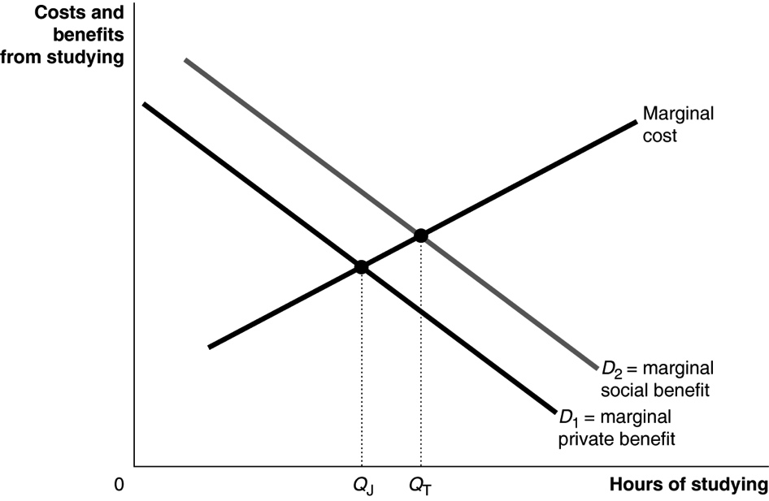

**1.13** **a.** As a result of fracking, the supply of natural gas shifts to the right from *S*1 to *S*2, which lowers the equilibrium price of natural gas to *P*2 and raises the equilibrium quantity of natural gas to *Q*2.

**b.** Because *S*1 and *S*2 reflect only marginal private cost, fracking that results in a negative externality would result in *S*1 reflecting marginal social cost. So the efficient price is *P*1 and the efficient quantity is *Q*1.

**c.** Based on the graph drawn, the efficient price and quantity of natural gas are the same as the equilibrium price and quantity before fracking. However, it is hard to determine how the efficient price and quantity change because they depend on how much supply increases due to fracking and how large the external costs associated with the pollution from fracking are.

Ch05_Problem_1

**1.14** It is a positive externality in production. Because of the way the cable provider packages channels, popular programs on one channel will increase sales of other channels. It is possible to think of a private agreement in which other cable channels assume some of the production costs of popular shows, but negotiating such an agreement would be difficult.

**1.15** By market failures, he means that an unregulated market will result in more than the economically efficient amount of development of farmland. Inefficient land allocation refers to the conversion of farmland into developed land. Because the market fails to take into account the external cost of lost farmland, an inefficiently large quantity of land (*Q*1) is developed. The efficient level of land development is *Q*2, which is determined by the intersection of demand and *S*2.

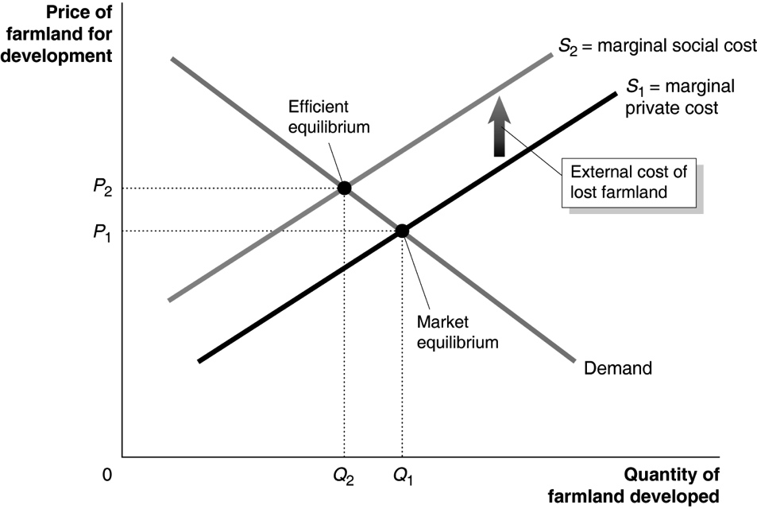

|  |  |
| --- | --- |
| **5.2** | Private Solutions to Externalities: The Coase Theorem  Learning Objective: Discuss the Coase theorem and explain how private bargaining can lead to economic efficiency in a market with an externality. |
|  |
|  |

Review Questions

**2.1** The economically efficient level of pollution is the quantity at which the marginal cost of eliminating another unit just equals the marginal benefit from eliminating it. The economically efficient quantity of pollution isn’t zero in most cases. Eliminating all pollution would incur costs that are greater than the benefits.

**2.2** The Coase theorem argues that if transactions costs are low, private bargaining will result in an efficient solution to the problem of externalities. Parties involved in an externality have an incentive to reach an efficient solution because the benefits from reducing an externality are often greater than the costs.

**2.3** Transactions costs are the costs in time and other resources that parties incur in the process of agreeing to and carrying out an exchange of goods or services. Private solutions to the problem of externalities are most likely when it is easy to define and enforce property rights and when the costs of making a deal are low.

Problems and Applications

**2.4** An increase in pollution could make society better off if the current level of pollution is below the efficient quantity. For example, government regulations could be so strict that they require pollution reductions to level *A* in the figure below. The marginal cost of the last unit of pollution reduction exceed the marginal benefit, so society would be better off if pollution reduction was only level *B*—the efficient quantity.

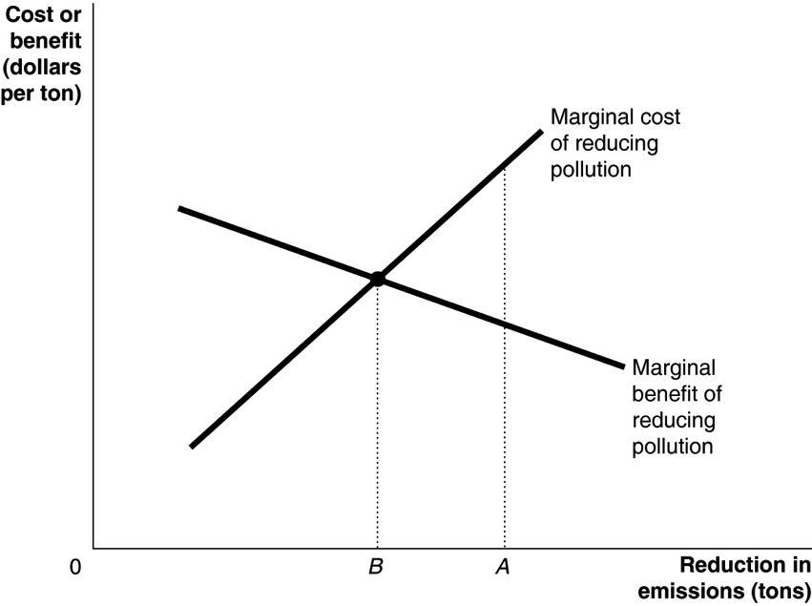

**2.5** Yes, assuming that the marginal benefit does not drop to zero before all of that type of pollution is eliminated.

**2.6** The marginal cost of reducing crime would include resources devoted to police, courts, and prisons. The marginal benefit to reducing crime would include the reduction in losses to crime victims, including losses due to personal injury, stolen goods, and anxiety. Just as with pollution, it would not be economically efficient to reduce the amount of crime to zero. In other words, there is an economically efficient level of crime where the marginal benefit from crime reduction equals the marginal cost.

**2.7** As the level of pollution falls, further cleanup becomes increasingly costly because the marginal cost curve typically is upward sloping. For example, developing countries that have significant air pollution can use existing technology. Proven pollution reduction methods can be implemented at the beginning of the cleanup process, so air pollution resulting from automobile or factory emissions can be addressed. Because significant technological advances have already been made in these areas, the cost of implementation would be relatively low. Cleaning up the last 10 percent would be considerably more expensive because a low-cost method to completely eliminate air pollution in populated, urban areas has yet to be developed. An important trade-off involves spending resources to develop a method to completely eliminate air pollution versus using those resources for other purposes, such as education.

**2.8** **a.** As the level of pollution falls, additional reductions in pollution become more costly. To reduce pollution further will likely require new technology and innovation, which can be expensive. The additional benefit to society of less pollution will decrease, so if the marginal benefit is less than the marginal cost, society is actually worse off as a result of the pollution reduction.

**b.** Although there would be health benefits of reducing pollution further, it is not clear that the government should take action to do so. If the marginal benefit of reducing air pollution is greater than the marginal cost, further reductions will make society better off. But if the marginal cost of reducing air pollution is greater than the marginal benefit, reducing air pollution will actually make society worse off. The government needs to quantify the marginal cost and the marginal benefit of a further reduction in air pollution, and take steps to reduce air pollution further only if the marginal benefit exceeds the marginal cost.

**2.9** Economists would typically disagree because in deciding on the optimal amount of pollution reduction, we must take into account the costs as well as the benefits. Because the marginal benefit of reducing sulfur dioxide emissions all the way to zero will be very low, while the marginal cost will be very high, it would not be economically efficient to completely eliminate sulfur dioxide emissions.

**2.10** If the group affected by the air pollution offered the steel plant an amount of money to curtail production that was equal to or greater than the marginal cost of the air pollution, it would be in the interest of the steel plant to internalize the cost of the air pollution. The amount offered to curtail each unit of production would be an opportunity cost (because the steel plant would lose the funds if it did not curtail production) and would become part of the steel plant’s marginal cost of production. The property right to clean air does not need to be assigned to the victims of air pollution to get the steel plant to reduce pollution. As just noted, if the steel plant has the property right, but the victims offer the plant an amount at least equal to the marginal cost of the air pollution, then the plant will internalize the cost of the air pollution and reduce the quantity of pollution it emits.

**2.11** It seems likely that private agreements will result in something close to the efficient quantities of apple trees and beehives. We know that private agreements are detailed and enforceable, so it is likely that the externalities can be internalized successfully. However, the transactions costs involved in negotiating the agreements may result in the efficient quantities of apple trees and beehives not being attained exactly.

|  |  |
| --- | --- |
| **5.3** | Government Policies to Deal with Externalities  Learning Objective: Analyze government policies to achieve economic efficiency in a market with an externality. |
|  |
|  |

Review Questions

**3.1** A Pigovian tax aims to bring about an efficient level of output in the presence of externalities. The tax is set equal to the marginal external cost, which is the difference between the marginal social cost and the marginal private cost.

**3.2** To internalize an externality means that the producer or consumer that creates the externality bears the costs or receives the benefits of the externality. A tax equal to the cost of a negative externality will cause producers to internalize the negative externality, and a subsidy equal to the benefits of a positive externality will cause consumers to internalize a positive externality. A private solution along the lines of the Coase theorem would also internalize an externality.

**3.3** Most economists prefer tradable emissions allowances because they allow pollution to be reduced at the lowest cost. The firm that can reduce pollution cheaply will do so and sell its right to emit pollution to another firm whose costs of reducing pollution are high. The command-and-control approach is generally much costlier, and therefore less efficient, because it often forces firms to adopt expensive methods of pollution control.

Problems and Applications

**3.4** A Pigovian tax is set equal to the marginal cost of an externality. In the absence of the tax, consumers have to bear the cost of the externality. For example, in the absence of a Pigovian tax on a factory that emits air pollution, consumers are bearing the cost of breathing polluted air. So in that sense, consumers are “paying” an amount equal to a Pigovian tax even if the government has not imposed the tax.

**3.5** Consuming fruits and vegetables has a positive externality to the extent that such consumption decreases medical expenses, which decreases the costs of private health insurance for all people who have insurance and also decreases the cost of the government’s Medicare and Medicaid programs. Whether the government should subsidize the consumption of fruits and vegetables is complex policy issue. It may be difficult for the government to accurately measure the size of the positive externality from consuming fruits and vegetables. The government should also take into account that the people who consume fruits and vegetables may live longer and receive more publicly provided benefits, such as Social Security payments and Medicare benefits. The additional cost of providing these government benefits offsets some of the effects of the positive externality from consuming fruits and vegetables.

**3.6** The production of antibiotics creates a positive externality to the extent that the value of new antibiotics to society exceeds the profits pharmaceutical companies earn from producing the antibiotics. Whether every firm producing a good with a positive externality should receive a subsidy depends partly on how large the positive externality is. The positive externality would need to be larger than the government’s transactions cost or administrative cost of providing the subsidy.

**3.7 a.** Annoying people, including babies who cry on busses and planes, cause a negative externality because they impose costs on other people around them. Taxing annoying people, including the parents of the crying children, may discourage people from being annoying (or encourage parents of crying babies to find alternative methods of keeping their children quiet). However, the administrative costs of monitoring crying babies and taxing their parents would be very high. In addition, many people might oppose such a tax because it would represent a government intrusion into what is usually considered a private matter.

**b.** People who plant flowers cause a positive externality because they give benefits (for instance, higher property values) to other people in the neighborhood. Government subsidies may encourage more people to plant flowers, but again, the administrative costs of identifying beautiful gardens and deciding on the appropriate subsidy would be very large.

**c.** Every negative externality should not be taxed, and every positive externality should not be subsidized. The government should compare the costs of imposing taxes and subsidies to the benefits. So if the benefits associated with a Pigovian tax outweigh the costs, a Pigovian tax would reduce deadweight loss (and increase efficiency). In the cases discussed in parts (b) and (c) of this problem, administrative costs would likely be too high for taxes or subsidies to be an effective way of dealing the externalities involved.

**3.8** Yes, subsidizing something that generates external benefits can help increase economic efficiency. However, the funds used to subsidize new technologies may be wasted if the government subsidizes new technologies that don’t generate enough external benefits to justify the cost of the subsidy. The U.S. government does subsidize the prooduction of new technology by providing grants to researchers through the National Science Foundation and other agencies, as well as granting monopoly privileges through patents and copyrights. Of course, distinguishing between “good” new technologies and mediocre new technologies is a very difficult task.

**3.9** In the graph below of the market for gasoline, the equilibrium price is initially *P*market and the equilibrium quantity is *Q*Market. An increase in the tax on the sellers of gasoline would shift supply from *S*1 to *S*2, resulting in an efficient price of *P*Efficient and an efficient quantity of *Q*efficient. In the graph on page 151, consumers are paying a price *P*, which corresponds to the price *P*Efficient in the graph below. So regardless of whether the gasoline tax is imposed on the buyer or the seller, the price consumers pay for gasoline is increased to the efficient level.

**Ch05_Problem_3**

**3.10** **a.** The tax should be the amount necessary to shift up the supply curve from *S*1 to *S*2. That amount is $7.50 – $7.15 = $0.35 per item dry cleaned.

**b.** The deadweight loss from excessive dry cleaning arises because the efficient number of items to dry clean is 600,000 per week, but the market equilibrium is 750,000 per week. The following graph shows that the deadweight loss equals the amount by which the marginal social cost (*S*2) of cleaning the last 150,000 items exceeds the marginal benefit (the height of the demand curve for each of these items). The deadweight loss is shown by area *A* of the figure and has a value equal to: 0.5 × $0.35 × 150,000 = $26,250. (Note: We know that the base of the deadweight loss triangle must be $0.35 because *S*2 is parallel to *S*1, so the distance between them is constant.)

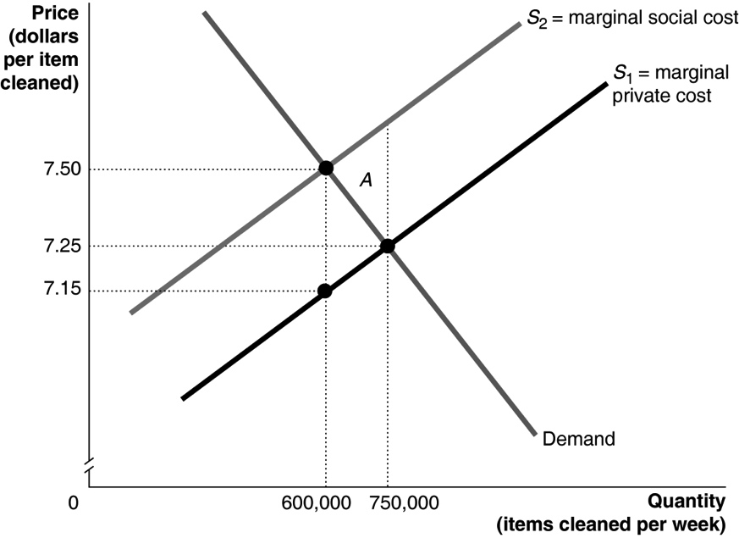

**3.11** The efficient level of toilet paper production will occur where the demand curve intersects with the marginal social cost curve. So the efficient level of production will be 350,000 tons, and the efficient price will be $150 per ton. If the government imposes a tax of $50 per ton (the difference between the marginal private cost and the marginal social cost), supply will shift from *S*1 to *S*2, resulting in the efficient price and quantity.

**Ch05_Problem3**

**3.12 a.** The “mortality effect” is the number of people who die prematurely. The number of people who die prematurely from being obese is less than the number of people who die from smoking. By living longer, people who are obese add more costs to society over their lifetimes. In particular, they are less likely than smokers to die before collecting much in Social Security and Medicare benefits.

**b.** Far more people drink soda than smoke, so more people would visibly notice (and be affected by) taxes on sodas. In addition, with so much discussion in the news over the years about the negative effects of smoking—including the effects on nonsmokers of “secondhand smoke”—more people are likely to accept taxes on cigarettes than on soda.

**3.13 a.** The efficient amount of crime is where the marginal benefit (from increased safety, reduced property losses, increased peace of mind, and so forth) of reducing crime equals the marginal cost (from the salaries of additional police officers, the cost of additional squad cars, the cost of building and operating additional prisons, and so forth) of reducing crime.

**b.** The tax is a Pigovian tax because it attempts to push the quantity of crime toward its efficient level. Assuming that the marginal benefit of reducing crime is currently greater than the marginal cost—so that the current level of crime is inefficiently high—Governor Patrick’s proposal would increase economic efficiency.

**3.14** **a.** Marginal external cost is the difference between the marginal social cost and the marginal private cost curve. In this case, the marginal external cost must be rising as output increases, so the gap between the marginal private cost curve and the marginal social cost curve gets larger as output increases.

**b.** The optimal Pigovian tax can be found by first finding the efficient level of output, which is found at the intersection of the demand curve and the marginal social cost curve. At this output, the optimal tax equals the gap between the social cost and the private cost curves—that is, it equals the amount of the marginal external cost. Therefore, in the large city the optimal tax is $6.60 − $5.40 = $1.20, but in the small city the optimal tax is only $5.60 – $5.00 = $0.60. The efficient tax is larger in the large city because demand is greater and marginal social cost increases as the quantity of items cleaned per week increases.

**Ch05_Problem_3_14**

**3.15** Command-and-control rules are when the government imposes quantitative limits on the amount of pollution firms are allowed to emit or require firms to install specific pollution control devices. Quantitative limits per power plant and specific pollution control devices can be very costly. In addition, when the government dictates the details of how pollution will be reduced, it fails to harness the ingenuity of business firms. After a carbon tax is imposed, utilities and car companies may develop new ways of reducing pollution that are more efficient than the ways the government dictates under a command and control system. Finally, with a carbon tax, firms generating more pollution have a greater incentive to reduce pollution than firms generating less pollution. The command-and-control approach, on the other hand, is “one size fits all.”

**3.16 a.** The burden of a tax refers to who actually ends up paying the tax. In this case, the Congressional Budget Office report suggests low-income households would disproportionately pay more of the carbon tax in the form of higher gasoline and electricity prices.

**b.** Because lower-income households spend a larger fraction of their income on gasoline, heating fuel, and electricity, they would bear a proportionally larger share of the tax. One way to reduce the burden on these households would be to give them tax rebates.

|  |  |
| --- | --- |
| **5.4** | Four Categories of Goods  Learning Objective: Explain how goods can be categorized on the basis of whether they are rival or excludable and use graphs to illustrate the efficient quantities of public goods and common resources. |
|  |
|  |

Review Questions

**4.1** Rivalry occurs when one person’s consumption of a unit of a good means that no one else can consume it. Excludability occurs when anyone who doesn’t pay for a good cannot consume it. Goods that are both rival and excludable are called private goods, which are most of the goods we consume. Goods that are rival, but nonexcludable, are called common resources—such as fish in the sea. Goods that are both nonrival and nonexcludable are called public goods. Goods that are nonrival, but excludable, are called quasi-public goods.

**4.2** Free riding is benefitting from a good without paying for it. A public good is nonrival and nonexcludable. Because anyone can get it without paying for it once it has been produced—attempting to “free ride” in this manner—there is often little incentive for firms to supply the good because they can’t cover their costs if people don’t pay for the good. Free riding will lead to market failure: Less than the economically efficient amount of a public good will be produced.

**4.3** The tragedy of the commons is the tendency of a common resource to be overused. It can be avoided if there is a way to block overuse. One method is to give someone or some group a property right to the resource, which would give the person or group the incentive to use it efficiently. However, this won’t work well if the person or group cannot easily enforce the property right.

Problems and Applications

**4.4** **a.** The optimal quantity of a public good is the quantity where the public’s marginal benefit from the good—as represented by the demand curve—is equal to the marginal cost of providing the good. To solve the problem, we need to know the demand curve for the city park and the marginal cost to the town of providing acres of park land. To calculate their overall demand, we need to add the dollar amounts that Jill and Joe are willing to pay for each quantity:

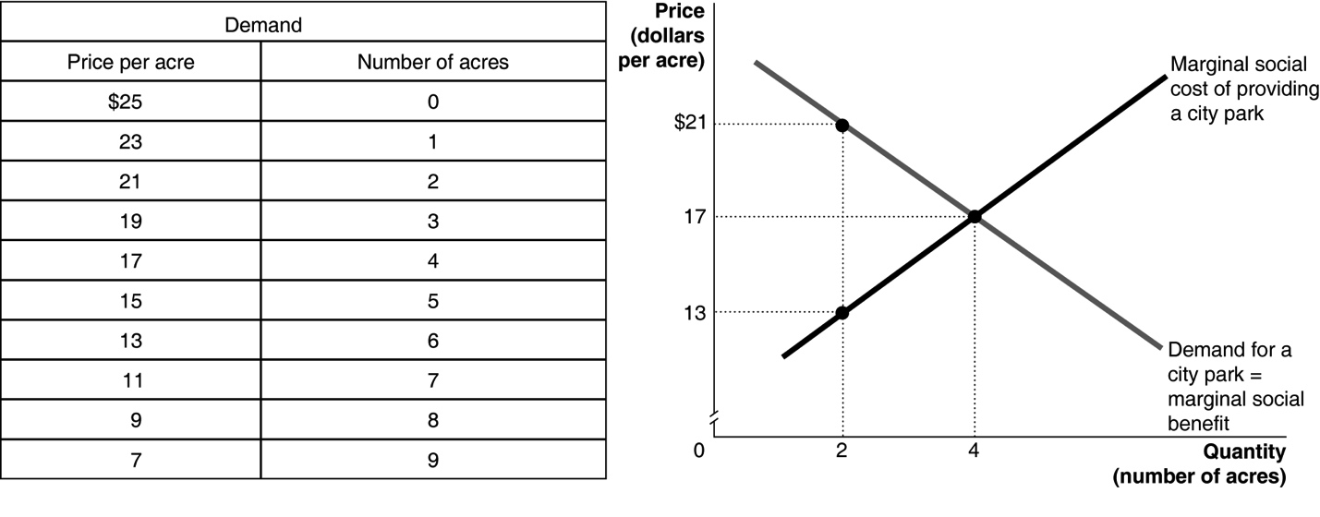

The graph shows that the optimal size park—where marginal social cost equals marginal social benefit—is four acres.

**b.** The marginal cost of supplying the second acre is $13. But the demand curve tells us that the marginal benefit Jill and Joe receive from the second acre is $21. Because the marginal benefit to society is well above the marginal cost, two acres cannot be the optimal size for the town park.

**4.5** The tragedy of the commons is the tendency for a common resource to be overused. Because whales are a common resource, in the absence of agreements among governments to control whaling, several species have been hunted to near extinction.

**4.6** Clean air and the village green are both common resources: They are rival and not excludable. Just as one farmer using the pasture leaves less grazing space for the other farmers, one person polluting the air leaves less clean air for other people. Because they are not private goods, neither the pastureland nor the air can be excluded from use.

**4.7** The tragedy of the commons arises because each person using the commons neglects the effects his use has on other users. This is similar to each person neglecting to take into account the effects on others—in the form of creating resistant microorganisms that cause hard-to-treat infections—from using antibiotics.

**4.8** Private goods are (b) home mail delivery (you’ll be excluded if you don’t use a stamp), (d) education in a private school, and (g) an apple. Public goods are (a) television broadcast (assuming that it an over-the-air broadcast; a cable broadcast would be a quasi-public good because it is excludable but not rival) and (f) hiking in a park without a fence. Hiking in a park surrounded by a fence (e) is a quasi-public good because it is excludable but not rival. Education in a public school (c) is a common resource—at least for people within the school district who won’t be excluded. It is rival because as more students crowd into a classroom, the amount of attention the teacher gives to each student declines. In cases where it isn’t rival, it would be a public good for those who are eligible.

**4.9** A few aspects of health care indeed do generate large positive externalities that are not excludable and in these cases it is likely that a private system will not provide the efficient amount. But these cases (such as vaccines) are a relatively small share of the total health care market. Most services (such as an appendectomy or open heart surgery) are private because they are rival and excludable, and the reason for the government to provide them cannot be due to their being public goods. There may be other reasons the market does not provide the efficient quantity of these services, such as patients, medical care providers, and insurance companies not all having access to the same information, distortions due to individuals not being taxed on the medical insurance provided by their employers, and the overuse of health care by the insured.

**4.10** The land where several clubs hunt is similar to a commons. If one hunt club does not harvest the small buck, another club will. The land where the club has exclusive rights is similar to private property, where the hunt club can control overharvesting.

**4.11** Buffalo on the Great Plains during the 1800s were a common resource (rival, but not excludable) and were overharvested to near extinction. Cattle were privately owned and, therefore, not overharvested.

**4.12** The village elders were trying to prevent the tragedy of the commons. Their solution worked quite well given the small size of the village.