CHAPTER 6 | Elasticity: The Responsiveness of Demand and Supply

Solutions to End-of-Chapter Exercises

|  |  |
| --- | --- |
| **6.1** | **The Price Elasticity of Demand and Its Measurement**  Learning Objective:Define price elasticity of demand and understand how to measure it. |

Review Questions

**1.1** Price elasticity of demand = (percentage change in quantity demanded)/(percentage change in price). Price elasticity of demand isn’t measured by the slope of the demand curve because the slope depends on the units of measurement. The slope of the demand curve will change by a factor of 100 if you use cents instead of dollars, for example. Or, for another example, consider six-packs of soda versus cans of soda: If the price drops by $1.00 per six-pack and the quantity demanded increases by two six-packs, then that is the same thing as quantity demanded increasing by 12 cans. So, you could calculate the slope either as −1/2 six-packs, or as −1/12 cans. In addition, using percentage changes in the elasticity formula allows for meaningful comparisons of demand responsiveness between very different kinds of goods: for example, breakfast cereal versus health care. Because the slope uses physical units of quantities, such comparisons are impossible.

**1.2** The price elasticity of demand =



The demand for Cheerios would be elastic.

**1.3** In calculating the percentage change in price and quantity, the midpoint formula divides by the average of the starting and ending values.

Midpoint formula: 

Percentage changes can also be calculated by using the starting or ending value without averaging, but this method gives different results depending on whether the starting or ending value is used.

**1.4** A perfectly inelastic demand curve is a vertical line, as shown at the bottom of Table 6.1. Such a good will have no substitutes—for example, a life-saving drug.

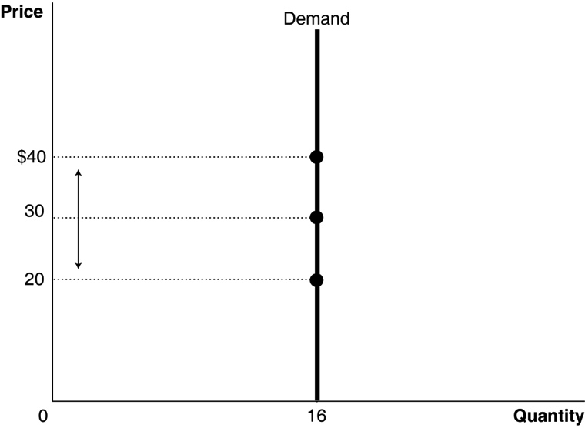

Problems and Applications

**1.5** The demand is inelastic. The percentage change in quantity demanded is less than the percentage change in price.

**1.6** **a.** 

**b.** . This is a much smaller value than in (a).

**c.** We can calculate the price elasticity using the midpoint formula as follows:

Percentage change in quantity demanded = 

Percentage change in price = 

So, the price elasticity of demand = 

Notice that this value is significantly different from the values calculated in (a) and (b).

**1.7** For *D*1:

Percentage change in quantity demanded = 

Percentage change in price = 

Elasticity = 

For *D*2:

Percentage change in quantity demanded = 

Percentage change in price = 

Elasticity = 

**1.8 Step 1:** Calculate average quantity and average price:

Average quantity = 

Average price = 

**Step 2:** Calculate percentage change in quantity demanded and percentage change price:

Percentage change in quantity demanded = 

Percentage change in price = 

**Step 3:** Divide the percentage change in the quantity demanded by the percentage change in price to arrive at the price elasticity for the demand curve:

Price elasticity of demand = 

Demand for Pace University is therefore *elastic.*

Total tuition received in 2006 declined to $33,312,474 from $36,359,219 in 2005.

**1.9** Suppose Ford did cut the price by $1 from $440 to $439 and quantity demanded increased by 1,000 cars from 500,000 to 501,000. The midpoint price would be $439.50 and the midpoint quantity would be 500,500. Then, the percentage change in quantity would equal: (1,000/500,500) × 100 = 0.20%. The percentage change in price would equal: (–$1/$439.50) × 100 = –0.23%. The price elasticity of demand is: 0.20%/–0.23% = –0.87. If Ford’s belief about the responsiveness of the quantity demanded for Model Ts to a change in their price was accurate, then the demand for Model Ts was price inelastic.

**1.10** At a higher price, quantity demanded will decrease, so the total revenue (price × quantity sold) will still be less than the total cost. Only in the very unlikely case where the demand for the magazine is perfectly inelastic would the publisher’s analysis be correct.

|  |  |
| --- | --- |
| **6.2** | **The Determinants of the Price Elasticity of Demand**  Learning Objective:Understand the determinants of the price elasticity of demand. |

Review Questions

**2.1** The demand for most agricultural goods is inelastic. Food is a necessity, and the demand for necessities tends to be less elastic than the demand for luxuries.

**2.2** The most important determinant of the price elasticity of demand is usually the availability of substitutes for the product. If there are close substitutes, elasticity will be high because people can switch to buying another good as the product’s price rises. Other factors determining the price elasticity of demand for a product include the passage of time, whether the good is a necessity or a luxury, how narrowly the market for the good is defined, and the share of the good in the consumer’s budget.

Problems and Applications

**2.3** Milk (a) and prescription medicine (d) are likely to be price inelastic due to lack of substitutes, but frozen cheese pizza (b) and cola (c) are likely to be price elastic because they have good substitutes, though we would expect a more narrowly defined product, such as Coca-Cola, to be more elastic than a broadly defined product such as cola.

**2.4** The more narrowly a market is defined, the more elastic demand will be, because more substitutes are available. The price elasticity of Coca-Cola (or any specific brand of soda) will be higher than for soda as a product because there are more substitutes available for a specific product like Coca-Cola than there are for a product category like soda**.**

**2.5** It usually takes consumers some time to adjust their buying habits when prices change. The more time passes, the more elastic the demand for a product becomes. In the case of oil prices, a good part of the demand is driven by the demand for gasoline. Consumers are slow to react to changes in gasoline prices because doing so often involves buying new cars, moving closer (or further away) from work, and so on.

**2.6** As the gas mileage of conventional gasoline-powered cars increases, the demand for green cars is likely to decrease. Because green cars generally are more expensive, many consumers will buy conventional gasoline-powered cars if the gas mileage is comparable. So the availability of a substitute makes the demand for green cars more price elastic.

**2.7** **a.** We can’t know with certainty from the information given whether in this case demand will be elastic or inelastic. We can say, though, that with a normal downward-sloping demand curve, the quantity demanded is lower at a price of $25 than at a price of $12. Along such demand curves, elasticity is not constant at every point. When the price is high and the quantity demanded is low, demand is more likely to be elastic. So we would expect the demand by visitors in private, noncommercial vehicles to be elastic. Of course, $25 might be such a small share of a typical household’s budget that, overall, the demand might be inelastic.

**b.** Once again, we can’t answer this question with certainty from the information given. But with a normal downward-sloping demand curve, the quantity demanded is lower at a price of $25 than at a price of $12. Along such demand curves, elasticity is not constant at every point. When the price is high and the quantity demanded is low, demand is more likely to be elastic. So we would expect the demand by visitors in private, noncommercial vehicles to have the largest price elasticity of demand. By similar reasoning, when the price is low and the quantity demanded is high, the demand is more likely to be inelastic. So we would expect the demand by visitors on foot, bikes, and skis to have the smallest price elasticity of demand.

|  |  |
| --- | --- |
| **6.3** | **The Relationship between Price Elasticity of Demand and Total  Revenue**  Learning Objective:Understand the relationship between the price elasticity of demand and total revenue. |
|  |

Review Questions

**3.1** If demand is inelastic, an increase in price will increase revenue because the price will increase proportionally more than the quantity sold will decrease.

**3.2** If revenue increases when price falls, then demand must be elastic.

Problems and Applications

**3.3** The larger the share of a good in an average consumer’s budget, the more elastic demand is. So the price elasticity of demand would likely be greater if consumers spend 8 percent of their incomes on gasoline rather than 4 percent.

**3.4** Elasticity = (percentage change in quantity/percentage change in price). The article states that consumption decreases by 3 to 5 percent in response to a 10 percent increase in price, so the range of elasticity is: (−3/10) = −0.3 to (−5/10) = −0.5. Demand for cigarettes is inelastic because the elasticity values computed are both less than 1 in absolute value. Because demand is inelastic, if price increases, revenue will also increase.

**3.5** The Port Authority is assuming that an increase in tolls will increase the total amount collected, so they must be assuming that demand is inelastic. The Port Authority might have reasoned that the demand for using bridges and tunnels to cross the Hudson River was inelastic because commuting is more of a necessity than a luxury, and for many commuters, there may not be any good substitutes.

**3.6** **a.** We can calculate the price elasticity along *D*1 between points *A* and *C* as follows:

Percentage change in quantity demanded = 

Percentage change in price = 

So, the price elasticity of demand = 

Similarly, the price elasticity of demand along *D*2 between points *A* and *B* can be calculated as follows:

Percentage change in quantity demanded = 

Percentage change in price = 

So, the price elasticity of demand = 

Because the quantity response is much larger for the same price cut, demand curve *D*1 is much more elastic.

**b.** Along *D*1, revenue increases from $3 × 200 = $600 to $2.50 × 300 = $750. Revenue rises by $150 as the price is cut because this demand curve is elastic. Along *D*2, revenue falls from $600 to $2.50 × 225 = $562.50. Revenue falls by $37.50 as the price is cut because *D*2 is inelastic.

**3.7** The sportswriter is assuming the price elasticity of demand for Indians’ tickets is inelastic. If the demand for Indians’ tickets is inelastic, then a decrease in price will lead to a decrease in total revenue.

**3.8** Manager 2 is wrong. Cutting the price will increase revenue if demand is price elastic. But notice that Manager 1 is just as wrong to say “only” as Manager 2 was to say “never.” Manager 1 says the only way to boost revenue is by cutting the price, but if demand is inelastic, then cutting the price will decrease revenue, not increase it.

**3.9** If an increase in price resulted in an increase in revenue, demand must have been price inelastic. However, as Figure 6.3 on page 183 shows, if the demand curve is linear, beyond some point demand will become elastic, and increases in price will result in decreases in revenue.

**3.10 a.** No. If the demand for the publisher’s books is inelastic, then an increase in price will increase total revenue.

**b.** The author of the article is assuming the demand for the publisher’s books is elastic. If demand for the books is elastic, an increase in price will decrease total revenue.

**3.11** First, we need to convert the dollar revenues into quantities:

December 2007: Quantity of cars parked = $1,387,000/$10 = 138,700

December 2008: Quantity of cars parked = $1,448,000/$16 = 90,500

Percentage change in quantity = (–48,200/114,600) × 100 = –42.1%

Percentage change in price = ($6/$13) × 100 = 46.2%

Price elasticity = –42.1%/46.2% = –0.911. Demand is price inelastic.

**3.12** **a.** For the Route 22 bridge:

Percentage change in quantity demanded = 

Percentage change in price = 

Therefore, the price elasticity of demand = 

For the Interstate 78 bridge:

Percentage change in quantity demanded = 

Percentage change in price = 66.7%.

Therefore, the price elasticity of demand = 

**b.** Total revenue in November was (519,337 + 728,022) × $0.50 = $623,679.50. In December total revenue increased to (433,691 + 656,257) × $1 = $1,089,948. The increase occurred because the demand at both bridges is price inelastic.

|  |  |
| --- | --- |
| **6.4** | **Other Demand Elasticities**  Learning Objective:Define cross-price elasticity of demand and income elasticity of demand and understand their determinants and how they are measured. |
|  |
|  |

Review Questions

**4.1** Cross-price elasticity of demand equals the percentage change in quantity demanded of one good divided by the percentage change in the price of another good. If the cross-price elasticity is negative, then the goods are complements; if it is positive, then they are substitutes.

**4.2** Income elasticity equals the percentage change in the quantity demanded divided by the percentage change in income. If the income elasticity is greater than 0, then the good is normal; if it is less than 0, then the good is inferior. Goods with income elasticities between 0 and 1 are often called necessities; goods with income elasticities greater than 1 are often called luxuries.

Problems and Applications

**4.3** **a.** Lettuce has the higher price elasticity because the percentage change in quantity demanded following a price increase is much larger for lettuce.

**b.** Positive. As the price of lettuce rises, the quantity demanded of the other green vegetables rises, so they are substitutes.

**4.4** To find the cross-price elasticity, divide the percentage change in the quantity demanded of buns by the percentage change in the price of hot dogs. At the initial price of buns ($1.20), the quantity demanded rises from 10,000 to 12,000, which is the change in quantity demanded that should be used.

Percentage change in quantity demanded = 

Percentage change in the price of hot dogs = 

So, the cross-price elasticity = 

Because the cross-price elasticity of demand is negative, we know these two goods are complements.

**4.5** (a) and (c) are substitutes, so the cross-price elasticities will be positive; (b) and (d) are complements, so the cross-price elasticities will be negative.

**4.6** **a.** The cross-price elasticity of gasoline and any gasoline-powered vehicles is negative, because gasoline and gasoline-powered vehicles are complements.

**b.** Gasoline and subcompact cars are complements, as are gasoline and SUVs. Subcompact cars and SUVs are substitutes.

**4.7** (a) Bread, (b) Pepsi, (d) laptop computers, (c) Mercedes-Benz automobiles is the most likely order. For normal goods that are considered necessities (such as food and clothing), their income elasticity is positive and less than 1. For normal goods that are considered luxuries (such as laptop computers and Mercedes-Benz automobiles), their income elasticity is positive and greater than 1. The items are ranked from most necessary to most luxurious.

**4.8** The more narrowly we define a market, the more elastic demand will be. So if data for only one brand of beer is used instead of multiple brands, demand for beer will likely be more elastic.

**4.9** During recessions, falling consumer incomes can cause firms selling luxury goods (goods with an income elasticity of demand greater than 1) to experience the largest decline in sales. During recessions, falling consumer incomes can cause firms selling inferior goods (goods with an income elasticity of demand less than 1) to see their sales increase the most.

|  |  |
| --- | --- |
| **6.5** | **Using Elasticity to Analyze the Disappearing Family Farm**  Learning Objective: Use price elasticity and income elasticity to analyze economic issues. |
|  |
|  |

Review Questions

**5.1** Increasing productivity in agriculture has brought about lower prices for food products as, over time, the increases in supply have dramatically outpaced increases in demand. Because the price elasticity of demand for food is low, the lower prices have not caused a large increase in quantity demanded. The increase in incomes over time has not increased the demand for food much because the income elasticity for food is low. Farmers, therefore, need to sell larger and larger quantities of food at lower and lower prices to raise the same revenue. As a result, small farms are no longer as profitable as they once were, and many people have abandoned farming to pursue other occupations.

Problems and Applications

**5.2** **a.** (Percentage change in price) × (price elasticity of demand) = percentage change in quantity: 50% × −0.25 = −12.5%. So, the quantity of cigarettes demanded should decline 12.5% from its current level of 360 billion per year. 12.5% of 360 billion is 45 billion.

**b.** Raising the tax on cigarettes is a more effective way to reduce smoking if the demand for cigarettes is elastic. With elastic demand, an increase in price resulting from a tax increase would result in a greater reduction in the quantity demanded of cigarettes than if the demand were inelastic.

**5.3 a. **

We can plug into the midpoint formula the values given for the price elasticity, the original price of $4.00, and the new price of $4.70 (= $4.00 + $0.70):

****

Or rearranging and writing out the expression for the percentage change in quantity demanded:

****

Solving for *Q*2, the new quantity demanded:

*Q*2 = 128.07 billion gallons.

Because the price elasticity of demand for gasoline is low (−0.55), an 18 percent increase in price of gasoline leads to only about 8 percent decline in gasoline consumption per year.

**b.** The federal government would collect an amount equal to the tax per gallon multiplied by the number of gallons sold: $1 per gallon × 128.07 billion gallons = $128.07 billion.

**c.** The answers are similar to Solved Problem 6.5 on page 188. Even though demand for gasoline is more elastic in the long run than in the short run, the elasticity is still relatively low, so the decline in the quantity of gasoline demanded is relatively small, and the government collects a relatively large amount of tax revenue.

**5.4** For the government policy to be effective, the demand for bribes must be elastic. The more elastic the demand curve, the more effective the policy will be. On the graph, the burden of corruption before the policy is enacted is represented by the area 0*Q*1*AP*1. The burden of corruption after the policy is enacted is represented by the area 0*Q*2*BP*2.

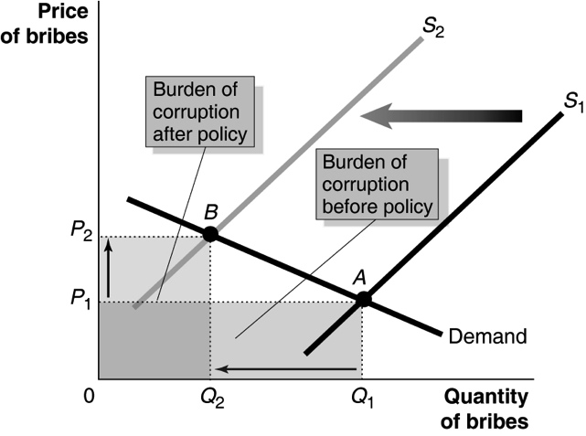

**5.5** His reasoning is correct: Because the demand for kumquats is elastic, a price increase resulting from the implementation of a price floor will decrease the revenue received by kumquat producers.

**5.6** We measure the loss of efficiency by the deadweight loss. When demand is elastic, the deadweight loss in the figure is *A*. When demand is inelastic, the deadweight loss is *A + B*. Therefore, the loss of economic efficiency from a price ceiling is greater when demand is price inelastic.

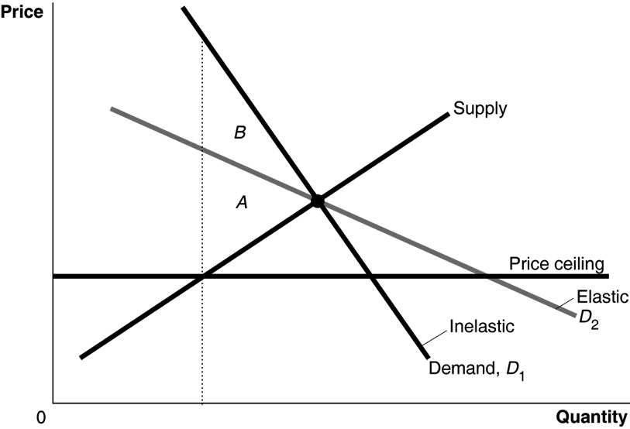

|  |  |
| --- | --- |
| **6.6** | **The Price Elasticity of Supply and Its Measurement**  Learning Objective:Define price elasticity of supply and understand its main determinants and how it is measured. |
|  |
|  |

Review Questions

**6.1** The price elasticity of supply = (percentage change in quantity supplied)/(percentage change in price). In this case, the elasticity of supply = 9%/10% = 0.9. The dividing point between elastic and inelastic is 1.0, so the price elasticity of supply for frozen pizzas is inelastic.

**6.2** The main determinant of the price elasticity of supply is time. The longer the time period, the more firms are able to adjust to a change in price. So, we would expect that as the time period increases the price elasticity of supply will increase. An exception to this rule is products that require use of a resource that is in fixed supply, such as wine from a particular region in France.

Problems and Applications

**6.3** If the supply of oil becomes more elastic, it will intersect demand curve *D*2 (Point *C*) at a price lower than $140 (*P*2) and at a quantity higher than 84 million barrels per day (*Q*2).

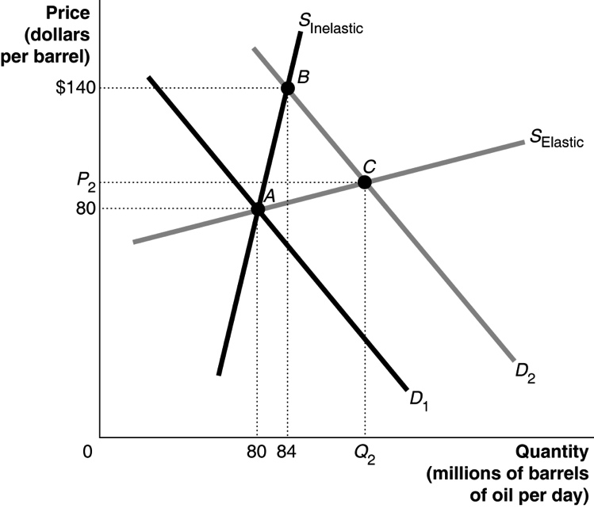

**6.4** To find price elasticity of supply, divide the percentage change in quantity supplied by percentage change in price. In panel (a), the percentage change in quantity supplied = , and the percentage change in price = . So, the price elasticity of supply =  In panel (b), percentage change in quantity supplied = , and the percentage change in price =  So, the price elasticity of supply = 

**6.5** This statement is correct. A longer period of time allows farmers to respond to an increase in demand for apples by planting more trees. So the supply curve is more elastic in the long run, and following an increase in demand, the price of apples will rise less in the long run than in the short run.

**6.6** The supply curve for many products will be inelastic if we measure it over a short period of time, but the supply curve will be increasingly elastic the longer the period of time over which we measure it. This conclusion applies also to resources including labor. Because it takes several years to train an engineer, in the short run the supply of engineers would not change much. In the long run, though, more students could be recruited and trained as engineers.

Conversely, if there is a decrease in demand for lawyers, in the short run there will a glut of lawyers. In the long run though, fewer people will go to law school, and the supply of lawyers will fall substantially.

**6.7** **a.**

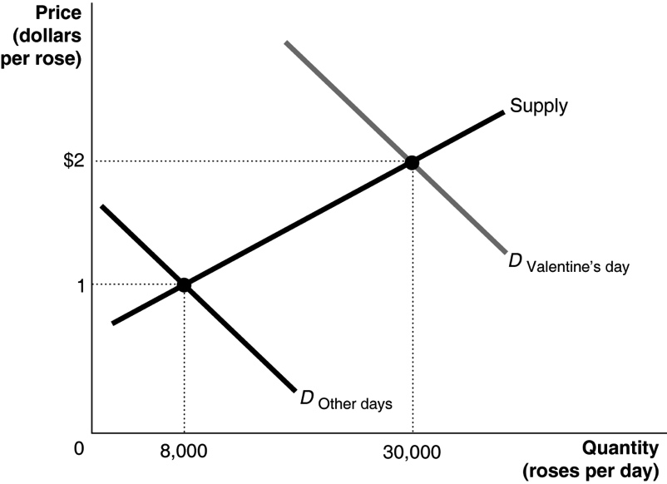

**b.** Based on this information, we don’t know much about the price elasticity of demand for roses. The demand curve has shifted, so the rise in the quantity of roses demanded is not caused by the rise in their price—and we can’t calculate the price elasticity of demand. We have a movement along the supply curve, so we can calculate the price elasticity of supply for roses.

The supply elasticity = (percentage change in quantity supplied)/(percentage change in price) =



The fact that the elasticity doesn’t have a negative sign is a reminder that with an upward-sloping supply curve, increases in price to lead to increases in the quantity supplied, so the price elasticity of supply must be positive.

**6.8 a.** Price elasticity of supply is the responsiveness of the quantity supplied to a change in price. In this case, it is zero, as the quantity supplied by the university does not change in response to changes in demand.

**b.** As shown in the graph below, when the demand curve for basketball tickets shifts from *D*1 to *D*2, the equilibrium price increases from $15 to $20, but there is no change in the equilibrium quantity.

**c.** One determinant of price elasticity of supply is the period of time. Over a longer period of time, the price elasticity of supply is more elastic. So although the supply curve for basketball tickets is perfectly inelastic, it is possible that over time, State University could build a larger basketball arena with more seats to accommodate more fans.

Ch06_Problem 6