CHAPTER 9 | Comparative Advantage
and the Gains from International Trade
Solutions to End-of-Chapter Exercises

9.1 | The United States in the International Economy  Learning Objective: Discuss the role of international trade in the U.S. economy.
Review Questions
1.1 Since the early 1980s, the value of U.S. exports has been smaller than the value of U.S. imports. In 2012, U.S. exports were about 14 percent of GDP, and U.S. imports were about 18 percent of GDP.
1.2 Since 1970, both exports and imports have been steadily increasing as a percentage of GDP. In 1970, exports and imports were both less than 6 percent of GDP, while in 2012, exports were about 14 percent of GDP, and imports were about 18 percent of GDP.
1.3 Although the United States is the world’s second largest exporter, Figure 9.3 shows that exports and imports as a share of total output (GDP) are smaller for the United States than for most other high-income countries. Because the United States has a large and diverse economy, the gains from trading with other economies probably aren’t as great as they would be if the U.S. economy were smaller and less diversified, like the economies of Belgium or South Korea.
Problems and Applications
1.4 Agriculture would see a large decline, as would many manufacturing industries. Many service industries, such as haircuts and medical services, would not be affected much because the United States does not export these types of services.
1.5 You should disagree. As Figure 9.3 shows, Japan is the only high-income country that is less dependent on international trade than the United States in terms of share of GDP that is exported.
1.6 Smaller countries generally do not produce as large and as diverse a group of goods and services as larger countries do. Smaller countries are, therefore, more likely than larger countries to export and import larger fractions of their GDP.
1.7 Goodyear sells more expensive tires than the primarily low-end tires imported from China. Also, Goodyear operates factories in China, and some of the tires produced there were exported to the United States and were subject to the tariff.

9.2 | Comparative Advantage in International Trade  Learning Objective: Understand the difference between comparative advantage and absolute advantage in international trade.
Review Questions
2.1 Absolute advantage is the ability to produce more of a good or service than competitors using the same amount of resources. Comparative advantage is the ability to produce a good or service at a lower opportunity cost than other producers. Comparative advantage, not absolute advantage, determines whether a country will be an exporter of a good, so a country will not necessarily be an exporter of a good in the production of which it has an absolute advantage.
2.2 Comparative advantage is the ability of an individual, a firm, or a country to produce a good or service at the lowest opportunity cost. This insight is powerful because it runs counter to most people’s intuition that trade is based on absolute advantage. Applying the concept of comparative advantage allows us to analyze which products countries tend to export and which they tend to import. The concept also allows us to see the immense gains—to rich and poor alike—that trading can generate.
Problems and Applications
2.3 The goods that countries import and export change over time because the goods in which they have a comparative advantage change over time due to changes in technology, the discovery of new natural resources or the depletion of existing natural resources, the accumulation of more machinery and equipment, the increased education and training of workers, and other factors.
2.4 Professor Wolak is referring to comparative advantage. Developing toys and other products often requires access to highly skilled designers. Manufacturing toys, on the other hand, can be done with relatively unskilled workers. The United States has a comparative advantage in designing toys and many other products, while China has a comparative advantage in the production of toys.
2.5 The argument is probably unsound because Bolivia most likely has a comparative advantage in producing at least one good. (The value of U.S. trade with Bolivia is not zero.) Remember that comparative advantage compares opportunity costs of producing goods between two countries. If the United States has a lower opportunity cost in one good, then it must have a higher opportunity cost in some other good, which would give Bolivia the comparative advantage in producing the other good.
2.6
Opportunity Costs
 | Olive Oil | Pasta
Greece | 0.5 pasta | 2 olive oil
Italy | 2 pasta | 0.5 olive oil
2.7 U.S. textile firms produce their goods at a higher opportunity cost than do the corresponding firms in China. By moving resources out of the textile industry, the United States can experience higher average incomes by freeing up resources to produce the goods in which it has a comparative advantage. These goods can then be traded for goods that can be produced at a lower opportunity cost elsewhere. A country increases its income by specializing in products where it has a comparative advantage, even if doing so means giving up production of products where it has an absolute advantage but not a comparative advantage.
2.8 Obama was referring to goods being produced in countries that have a comparative advantage in the production process. Comparative advantage refers to the ability of an individual, a firm, or a country to produce a good or service at a lower opportunity cost than competitors. Based on comparative advantage, some jobs in the United States will be lost to countries that have lower opportunity costs in producing certain goods and services. If T-shirts can be produced at a lower opportunity cost in another country, then it makes economic sense for T-shirts to be produced in that country. Although an individual who loses his job as a result of imports from another country may be justifiably upset and prefer to pay a higher price for a product to keep production at home, consumers in general are better off by purchasing goods from countries that have a comparative advantage in their production, as this will allow resources in the United States to be more efficiently allocated to goods and services in which the United States has a comparative advantage. In general, many people are unfamiliar with the concept of comparative advantage and fail to realize that trade restrictions destroy about as many jobs as they protect. So, Obama’s statement may accurately reflect public opinion.

9.3 | How Countries Gain from International Trade  Learning Objective: Explain how countries gain from international trade.
Review Questions
3.1 International trade increases a country’s consumption because it allows the country to specialize in the goods and services that it can produce at the lowest opportunity cost and trade for goods and services in the production of which it has a higher opportunity cost than other countries have.
3.2 Complete specialization would mean producing only one good. It is not typical for a country to completely specialize because not all goods and services are traded internationally. In addition, the production of most goods involves increasing opportunity costs, which means that before complete specialization is reached, a country may have lost its comparative advantage in producing a good. Finally, tastes for products differ across countries, so different countries may have comparative advantages in different types of the same good.
3.3 The main sources of comparative advantage are climate and natural resources, the relative abundance of various types of labor and capital, technology and know-how, and external economies.
3.4 Not everyone gains from international trade. Imports can result in some domestic firms being forced out of business and their workers losing their jobs. On balance, the losses due to international trade are more than offset by the gains, so on average, incomes rise as a result of international trade. But behind the averages, some people are made worse off, while others gain.
Problems and Applications
3.5 a. A country has an absolute advantage over another country when it can produce more of a good using the same resources. Chile has an absolute advantage in the production of both hats and beer because it can produce more of both goods (8 hats; 6 barrels of beer) than can Argentina (1 hat; 2 barrels of beer) with the same amount of labor input.
b. A country has a comparative advantage when it can produce a good at a lower opportunity cost. To produce 8 hats, Chile must give up 6 barrels of beer. Therefore, the opportunity cost to Chile of producing 1 hat is 6/8, or 0.75 barrel of beer. Argentina must give up 2 barrels of beer to produce 1 hat, so its opportunity cost of producing 1 hat is 2 barrels of beer. Chile has a comparative advantage in the production of hats because its opportunity cost is lower. To produce 6 barrels of beer, Chile must give up 8 hats, so its opportunity cost of producing 1 barrel of beer is 8/6, or 1.33 hats. Argentina must give up 1 hat to produce 2 barrels of beer, so its opportunity cost of producing 1 barrel of beer is 0.5 hat. Argentina has a comparative advantage in the production of beer because its opportunity cost is lower than Chile’s.
c. As part (b) shows, Chile should specialize in producing hats, and Argentina should specialize in producing beer. By specializing, Chile can produce 8,000 hats (1,000 labor hours × 8 hats), and Argentina can produce 2,000 barrels of beer (1,000 labor hours × 2 barrels of beer). If Chile trades 700 hats to Argentina for 700 barrels of beer, the countries will end up with:
 | Hats | Beer
Chile | 7,300 | 700
Argentina | 700 | 1,300
Both countries are better off than they were before specializing and engaging in trade.
3.6 The commentator is confusing absolute advantage and comparative advantage. Absolute advantage is the ability to produce more of a good or service than competitors when using the same amount of resources. Comparative advantage is the ability of an individual, a firm, or a country to produce a good or service at a lower opportunity cost than competitors. Every country, no matter how poor, will have a comparative advantage in producing some good. (Often countries are poor because they cannot or will not trade with others.)
3.7 As explained in the text, this statement is correct. Production of most goods and services involves increasing opportunity costs, so countries rarely become completely specialized.
3.8 Free trade probably benefits smaller countries more because without specialization and trade it would be difficult for producers in these countries to benefit from external economies and economies of scale. Also, larger, more populous countries are likely to have a wider range of both natural resources and people with particular skills, so these countries can gain from internal trade to a greater extent than is likely in smaller countries.
3.9 Although middle- and lower-income Americans may be losing jobs or receiving lower wages due to cheaper overseas labor, this same group benefits the most from the increased buying power that the imports from lower-income countries generate. Lower-income consumers spend a larger percentage of their income on manufactured goods than do higher-income consumers. Because the prices of manufactured goods are often reduced by free trade, lower-income consumers benefit the most from the low prices that result from free trade.
3.10 Opening up markets to trade allows a country to benefit from its comparative advantage by specializing in the goods for which it possesses a comparative advantage. By doing so, and altering the mix of goods that it produces, the country can use trade to obtain a combination of goods that it cannot produce on its own—reaching a point beyond its own production possibilities frontier. In this sense, a country can “produce more with less” and consumers are able to obtain greater benefits. See Table 9.4 in the textbook for a good example of trade leading to gains for consumers.
3.11 a. Tanzania produces 8,000 bushels of cashew nuts.
b. Tanzania will get 1,500 bushels of mangoes in exchange. Because point C (5,000 bushels of cashew nuts and 1,500 bushels of mangoes) is above the production possibilities frontier, Tanzania if better off with trade than without trade.
c. With trade, Tanzania is producing on its production possibilities frontier but consuming beyond its production possibilities frontier.
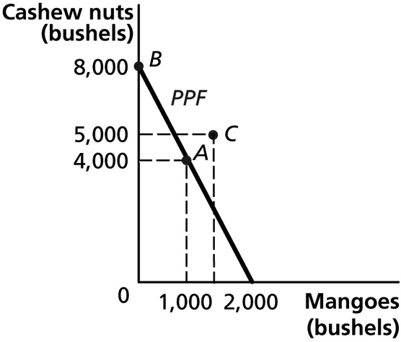
3.12 Both Colombia and the United States, considered as a whole, are likely to benefit from the trade agreement, but not everyone wins from expanding international trade. Some domestic suppliers and their workers lose if they are driven out of existing markets (and into new markets) by lower-priced imports.
3.13 Startup software firms located in the Bay Area can take advantage of the availability of skilled workers, the opportunity to interact with other software firms and entrepreneurs, and being closer to suppliers. Economists refer to these advantages as external economies. Similar to the advantages that Manhattan has for financial firms, the advantages the Bay Area has for startup software firms are likely to persist over time. Software firms located elsewhere may have a hard time overcoming the Bay Area’s advantages, because other locations do not have the conglomeration of software entrepreneurs, firms, and resource suppliers that can be found in the Bay Area.

9.4 | Government Policies That Restrict International Trade  Learning Objective: Analyze the economic effects of government policies that restrict international trade.
Review Questions
4.1 A tariff is a tax governments impose on imports. A quota is a numerical limit a government imposes on the quantity of a good that can be imported into the country. Non-tariff barriers include governmental rules—for example, health or safety regulations—that favor domestic firms over foreign firms.
4.2 The winners from tariffs are domestic firms protected by the tariffs, the firms’ workers, and the government, which collects the tariff revenue. The losers are domestic consumers and domestic firms that use as an input the product that is protected by the tariff or quota; for example, the U.S. candy industry loses as a result of the U.S. sugar quota. The winners from quotas are domestic firms protected by the quota, the firms’ workers, and whoever holds the import license.
Problems and Applications
4.3 In this context, economic nationalism refers to using tariffs, quotas, and non-tariff barriers to protect domestic industries. As explained in the text, a country benefits from free trade even if other countries do not engage in it. A country gains because, by trading, it can obtain goods and services at a lower opportunity cost.
4.4 Most economists would disagree. Reducing barriers to trade reduces the number of jobs in industries in which sales decline due to lower-priced imports, but it increases the number of jobs in export industries and in industries that use as inputs goods that had been protected by tariffs. Reducing barriers benefits consumers because it lowers the prices of imported goods.
4.5 a.
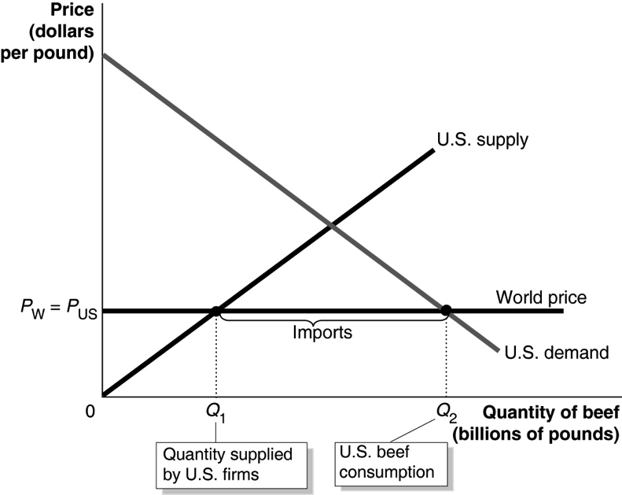
b.
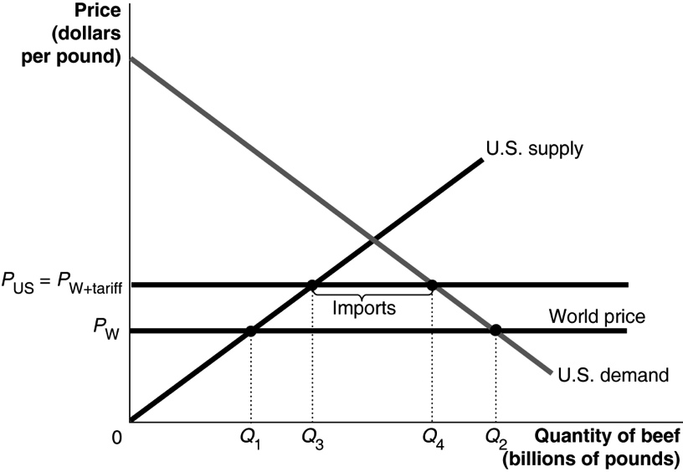
Before the tariff, the quantity of beef sold by U.S. producers is Q₁; after the tariff, the quantity of beef sold by U.S. producers is Q₃. Before the tariff, the quantity of beef imported = Q₂ – Q₁; after the tariff, the quantity of beef imported = Q₄ – Q₃. Before the tariff, the price of beef in the U.S. is P_{w} and after the tariff the price of beef is P_{W+tariff}.
c. The winners from the tariff are domestic producers of beef and the government, which collects the tariff revenue. The losers are domestic consumers of beef, U.S. firms—such as McDonald’s—that use beef as an input, and foreign suppliers.
4.6 Consumers pay more than domestic producers receive because foreign producers capture some of the benefits. In addition, consumers bear the cost of the deadweight loss that a quota imposes on the economy (for example, see Figure 9.7 in the textbook, which shows the effects of the sugar quota). A “straight handout” would be a direct payment by the government to the firms that would otherwise receive protection through a quota. The handout would be cheaper because it would avoid making consumers pay for both the gains received by foreign producers and for the deadweight loss that represents the economic inefficiency a quota imposes on the economy.
4.7 The student’s reasoning is flawed. As we saw in the chapter, placing a tariff on imports of a good does raise the price of the good. But the price charged by U.S. producers will also rise if foreign competition is entirely eliminated because eliminating imports will reduce the supply of the protected good in the U.S. market. Unless an existing tariff has already resulted in no imports of the product, banning imports of the good will cause its price to rise by more than the tariff would because the effect on supply will be greater. Also, if the imported goods are a different style or quality than the U.S. goods, then U.S. consumers will have a reduced variety of goods from which to choose.
4.8 Economists usually measure the standard of living by the goods and services that the typical person in a country is able to purchase. In this case, the Chinese government will have reduced the standard of living of its own people and raised the standard of living of people in the United States. The standard of living in the United States is raised because U.S. consumers are able to purchase Chinese goods at a price below their true cost of production. The standard of living in China is reduced because the government has used some of the country’s resources to cover the cost of goods that are sent to the United States. Subsidizing exports is essentially giving money away to foreign consumers.
4.9 a. Area D. Consumers cut back on the quantity of plastic combs purchased at the higher U.S. price with the tariff and lose the consumer surplus they were receiving from these purchases.
b. Area B. U.S. producers increase the quantity of plastic combs supplied at the higher U.S. price with the tariff but are less efficient than foreign producers, as reflected by the U.S. supply curve being above the world price over this range of production.
c. Area B plus Area D. The tariff reduces consumer surplus by the sum of areas A, B, C, and D. Area A is the increase in producer surplus to U.S. producers, area C is tariff revenue to the government, and areas D and B are the deadweight loss.
4.10 a. The gain in consumer surplus equals the sum of areas A, B, C, and D. Areas A, B, and C show the gain to consumers of paying the lower world price on the quantity of canned tuna that they were previously purchasing at the higher U.S. price caused by the tariff, and Area D shows the gain to consumers of purchasing more canned tuna at the lower world price.
b. Area A shows the loss in producer surplus, both from U.S. firms selling canned tuna at the lower world price and from their reducing the quantity they supply.
c. Area C shows the loss in government tariff revenue, which equaled the amount of imports multiplied by the tariff.
d. Area B plus area D show the gain in economic surplus. Consumer surplus increased by the sum of areas A, B, C, and D. Producer surplus decreased by area A and government tariff revenue decreased by area C, leaving a net gain of area B plus area D.
4.11 a. The United States practices sugar protectionism by imposing quotas on sugar imports to protect U.S. sugar producers.
b. Sugar protectionism hurts consumers who must pay more for sugar and goods with sugar in them. It harms candy manufacturers and other food manufacturers because they must pay more for their inputs (sugar), so they may also hire fewer workers.
c. Congress and the president haven’t eliminated the sugar quota because the gains to sugar producers and their workers are large, while the losses to any individual consumer are small. Therefore, supporters of the quota are willing to lobby for it and provide campaign donations to supporters of the quota, while most consumers are not even aware that the quota exists.
4.12 You can refer to the graph on page 287 in the text for guidance in filling out the table.
 | Without Quota | With Quota
World price of kumquats | $0.75 | $0.75
U.S. price of kumquats | $0.75 | $1.00
Quantity supplied by U.S. firms | 4 million | 6 million
Quantity demanded | 13 million | 12 million
Quantity imported | 9 million | 6 million
Area of consumer surplus | A + B + C + D + E + F | A + B
Area of domestic surplus | G | C + G
Area of deadweight loss | None | D + F
4.13 a. If the government imposes a tariff, area C shows the government tariff revenue, which equals the quantity of imports times the tariff.
b. If the government imposes a quota, area C shows the gain to foreign producers who can sell canned peaches in the United States at a price above the world price.
c. As a consumer, you probably don’t care because the price is the same with either the tariff or the quota. But as a taxpayer, you probably prefer the government receiving the tariff revenue, instead of the gain going to foreign producers.
4.14 A quota on steel imports raises the costs of producing goods that use steel. As a result, the prices of these goods rise, reducing the quantity sold and causing firms in these industries to reduce production and lay off some workers. Heavy steel users, such as the automobile industry, and those exporting goods made with steel would be most affected.
4.15 It would have been cheaper for the federal government to have raised taxes on U.S. consumers and given the money to tire workers rather than to have imposed a tariff. Several reasons could explain why the federal government doesn’t adopt this alternative policy. A tax tied directly to the transfer of income from taxpayers to workers would be more transparent than the tariff and so could meet with taxpayer resistance. Consumers may be unaware of the tariff on Chinese tires and most likely unaware of the full cost of the tariff because the gains to protected firms and workers are more visible than the losses to consumers and to firms whose costs will rise because of the tariff. A direct transfer of tax money to workers in the tire industry would be more unusual than the government imposing a tariff and might encounter more political opposition.

9.5 | The Arguments over Trade Policies and Globalization  Learning Objective: Evaluate the arguments over trade policy and globalization.
Review Questions
5.1 The collapse of world trade during the Great Depression and the desire to create a stable, prosperous world economy after World War II, led to the General Agreement on Tariffs and Trade. The WTO eventually replaced the GATT when member countries decided that a permanent international organization would be more effective at expanding international trade and working out agreements on trade in services and intellectual property rights.
5.2 Globalization is the process of countries becoming more open to foreign trade and investment. Some people oppose globalization because they believe it will make them worse off or will harm other people they care about—especially poor workers in developing countries. Some opponents of globalization believe that it undermines local cultures, especially in developing countries.
5.3 Protectionism is the use of trade barriers to shield domestic companies and their workers from foreign competition. The beneficiaries are the protected domestic firms and their workers. The losers are domestic consumers and domestic firms who cannot buy their inputs as cheaply. The main arguments for protectionism are that it saves jobs and protects high wages; allows “infant industries” a chance to get started and grow; and protects national security. It is important to weigh the benefits of each of these arguments against the costs.
5.4 Dumping is selling a product for a price below its cost of production. The losers from dumping are competitors of the firm that dumps (and the dumping firm itself if it is selling below its marginal cost). Consumers are the beneficiaries. The biggest problem in implementing anti-dumping laws is that it is difficult to measure firms’ costs, so it is difficult to determine if firms are dumping. Also, there are often sound economic reasons for selling goods below the cost of production. Domestic firms do this, so it is unclear why foreign firms should not.
Problems and Applications
5.5 Clinton was probably referring to child labor laws, minimum-wage laws, the rights to form unions, and laws to protect the health and safety of workers. The governments of most developing countries have resisted these proposals. They argue that when the currently rich countries were poor, they lacked these types of labor standards, and their workers received low wages. They argue that it is easier for rich countries to afford high wages and labor protections than it is for poor countries. They also point out that many jobs that seem very poorly paid and unsafe by the standards of high-income countries are often better than the alternatives available to workers in developing countries.
5.6 When the U.S. government puts a tariff on steel imports, it protects steelworkers in West Virginia at the expense of steelworkers in South Korea (and elsewhere) by artificially increasing the demand in the United States for steel produced by U.S. firms. Landsburg is expressing an opinion of how things ought to be, so he is making a normative statement. In expressing an opposing opinion, Redburn is also making a normative statement.
5.7 You should disagree with the statement because it doesn’t take into account the whole process of international trade. Buying a less expensive good from Brazil leaves a consumer with more money to spend on other domestic goods. In addition, buying a good from Brazil provides Brazilians with the funds to buy goods from the United States. Importing goods does not affect the total number of jobs in the United States. Buying only American-made products and limiting imports results in higher prices of the American-made products, which makes these products more expensive for Americans. When the United States imports products in the production of which it does not have a comparative advantage, it is able to purchase these imports more cheaply, which in turn helps U.S. consumers and may help increase jobs. In the cell phone and computer tablets example, the U.S. decision to import cell phones and export computer tablets expanded world production and consumption of these two goods and left employment in the United States unchanged.
5.8 a. Answers will vary. Foreign trade allows an economy to increase its standard of living over time by specializing in the goods and services in which it has a comparative advantage and trading those goods and services for the goods and services in which it does not have a comparative advantage. Even though foreign trade raises the standard of living of a country, domestic industries and its workers that do not have a comparative advantage will be worse off, particularly in the short run.
b. During an economic recession, the general public is understandably concerned about jobs, and may see foreign trade as a threat to U.S. jobs.
c. Younger people have a greater chance to train and acquire skills that prepare them for jobs in the industries in which the U.S. has the comparative advantage. Younger people may also be more open to change and globalization.
5.9 a. Tariffs promote production in industries in which a country does not have a comparative advantage. By getting rid of tariffs, Europe and the United States can specialize further in the industries in which they have a comparative advantage, thereby increasing their total production of goods and services.
b. It comes down to a normative judgment. Even though eliminating tariffs leads to a net economic gain for a country, certain groups, such domestic industries that do not have a comparative advantage, will be hurt.
5.10. Free trade is not likely to affect the total number of jobs in a country, though compared with the situation where the imposition of tariffs and quotas interfere with trade, there will be a change in the composition of jobs as some industries that compete against imported goods decline and industries that export goods expand.

