CHAPTER 15 | Monopoly and Antitrust Policy
Solutions to End-of-Chapter Exercises
15.1 | Is Any Firm Ever Really a Monopoly?  Learning Objective: Define monopoly.
Review Questions
1.1 A monopoly is a firm that is the only seller of a good or service that does not have a close substitute. A firm can’t have a monopoly if a close substitute for its product exists.
1.2 Because consumers in your town could buy hardware on the Internet or by driving to another town that has a hardware store, you would not have a monopoly under the narrow definition of the term. However, because competition from on-line sellers and stores in other towns may not be sufficient to eliminate your economic profits in the long run, you may have a monopoly in the broader sense of the term.
Problems and Applications
1.3 A monopoly is defined as a firm that is the only seller of a good or service that does not have a close substitute. Ty Cobb considered candlelight a substitute for electric lights, so from his point of view, the local electric company was not a monopoly.
1.4 Even though local cable television companies have a monopoly in providing cable service in a city, they face growing competition from satellite television companies such as DirecTV and Dish Network. In addition, many people now stream television programs by buying them from iTunes or Amazon, or by watching them on the networks’ Web sites. Typically, programs can only be streamed with a delay of day or more. If consumers view satellite television or delayed streaming of programs as close substitutes for cable television, then the cable companies no longer have a monopoly.
1.5 Yes, certain prescription drugs, for example, have no close substitutes. Economists generally define a monopoly as a firm that is the only seller of a good or service that does not have a close substitute. So, it is possible to have a monopoly on a product that has substitutes, as long as they are not close substitutes.
1.6 Google is concerned with its image, in some people’s eyes (including those of the federal prosecutors in the U.S. Justice Department), of being a monopolist. If it can broaden the definition of the market in which it operates, Google will appear to be a smaller firm in that market and therefore less likely to be accused of violating antitrust laws. Because companies use highway billboards to advertise their products, these billboards could compete with some of the products promoted on Google’s search engine. But, arguably, a billboard is not providing “close” competition to advertising on an Internet search engine.
1.7 Because a monopolist is defined as a firm that is the only seller of a good or service for which there are no close substitutes, Google would not seem to fit that definition if other search engines like Yahoo! and Bing can also be used to access YouTube. If other search engines cannot be used to access popular sites such as YouTube, then the case for considering Google to be a monopoly is strengthened.

15.2 | Where Do Monopolies Come From?  Learning Objective: Explain the four main reasons monopolies arise.
Review Questions
2.1 The most important ways a firm becomes a monopoly are through the following barriers to entry: (1) government blocks the entry of other firms into the market; (2) the firm has control of a key resource; (3) there are important network externalities in supplying the product; and (4) economies of scale are so large that one firm has a natural monopoly.
2.2 The government grants patents, copyrights, and trademarks because it hopes that in the long run society will be better off. The potential profits to be earned by the temporary monopoly will encourage more rapid technological progress and will encourage risk-taking on the part of firms (pharmaceutical companies, for example) that would otherwise not occur. Competition still exists, but it focuses more on coming up with new products and processes.
2.3 A public franchise is a firm that the government designates as the only legal provider of a good or service. It is doubtful that all or even most public franchises are natural monopolies. If they were, they wouldn’t need the government to restrict their competitors.
2.4 A natural monopoly arises when one firm can supply the entire market at a lower average total cost than can two or more firms. In these cases, the firm doesn’t need a special law or strategy to become a monopoly. The monopoly happens naturally.
Problems and Applications
2.5 The USPS is probably not a natural monopoly. If it were, it wouldn’t need a law banning competition. It would be able to provide mail delivery at a lower cost and charge a lower price than potential competitors, so no one would want to enter the industry. If the current law banning competitors were removed, firms would likely enter this market. Competitors have already entered portions of the market (such as delivering packages and overnight letters) where competition isn’t banned and seem eager to expand into additional sectors in the mail delivery business.
2.6 Extending the life of patents for pharmaceutical companies would allow them to charge the monopoly price for their drugs for a longer period and earn higher profits. This potential for higher profits would encourage them to develop more new products. Consumers would gain from having a wider range of medicines, but they would lose because the prices of the medicines would stay high longer. It is difficult to evaluate the net effect.
2.7 Book prices are higher than they would be without copyrights. If any publisher could print copies of John Grisham’s latest novel, competition would drive down the price. In this sense, a copyright is a tax on readers. Because publishers cannot print copies of an author’s book without the author’s permission, publishers pay authors much more than they would if there were no copyrights. In effect, a copyright gives an author a monopoly on any books the author writes. If copyrights were abolished, very few authors would be able to earn a living by writing. As a result, many fewer books would be written, which would make readers worse off.
2.8 Patents are granted to encourage firms to spend more money on research and development to create new products. If somehow firms did not incur any costs in developing new products, the issuance of patents would still be a motivator for firms because they would have the exclusive right to the products they develop.
2.9 There are only a limited number of countries in the world, which limits the number of customers in this market. Also, printing currency that is difficult to counterfeit requires specialized printing methods that might involve high fixed costs that would result in substantial economies of scale.
2.10 Legally, if someone else had developed a game similar to Hasbro’s Monopoly game before Charles Darrow, the name Monopoly could not be trademarked. And without the trademark, Hasbro would lose millions of dollars annually as other firms marketed similar games using the same title.
2.11 De Beers was concerned that used diamonds would be a close substitute for newly mined diamonds and reduce their monopoly power in the market. De Beers used advertising to convince people not to sell their diamonds. In particular, the advertising slogan, “A diamond is forever,” was designed to emphasize the sentimental value of diamonds, so people and their heirs would not sell the diamonds. Because the advertising campaign was successful, it greatly reduced the number of used diamonds that were available as substitutes for new diamonds. The reduction in the availability of a substitute shifted out the demand curve for new diamonds, increased prices, and increased De Beers’s profit.
2.12 A natural monopoly occurs when economies of scale are so large that one firm can supply the entire market at a lower average total cost than can two or more firms. Oil refining is not a natural monopoly because in the United States and other countries, there are multiple firms in the oil refining industry. We can conclude that economies of scale in oil refining are exhausted long before the level of production reaches the quantity demanded in the market. Moreover, if there were substantial scale economies, the government would not need to establish a monopoly; a monopoly would occur naturally.
2.13 We can calculate average total cost at each quantity.
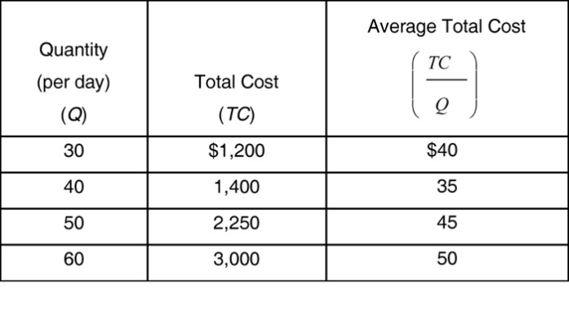
To have a natural monopoly, a firm must be able to produce at a lower average total cost than would two firms in that market. This is not the case here because the firm’s average total cost begins to increase after it has produced 40 units per day, well before the quantity demanded for the product, which is 90 units per day, is produced.
2.14 Because pharmaceutical firms that produce brand-name drugs are subject to damages from being sued, while manufacturers of generic drugs are not, the returns to manufacturing generic drugs are higher than they were before the Supreme Court’s decision. Presumably, more manufacturers will produce generic drugs, thereby reducing the profits of firms that sell brand name drugs. The result is likely to be that pharmaceutical firms will be less willing to invest in research and development of new drugs.

15.3 | How Does a Monopoly Choose Price and Output?  Learning Objective: Explain how a monopoly chooses price and output.
Problems and Applications
3.1 The monopolist’s demand curve is the market demand curve. The marginal revenue curve is derived from the demand curve. For a linear demand curve, the marginal revenue curve will be below the demand curve (and it is also twice as steep as the demand curve, because in absolute value, the slope of the marginal revenue curve will be twice the slope of the demand curve).
3.2 A monopolist is a price maker in the sense that if a monopolist raises its price, it will lose some, but not all, of its customers. No. The monopolist would only sell one unit to the consumer willing to pay the highest possible price. To maximize profit, the monopolist would charge a lower price—one that results in selling the quantity at which marginal revenue equals marginal cost.
3.3. Assume the graph below represents the market for Time Warner Cable’s basic cable package as an example of a monopolist earning a profit.
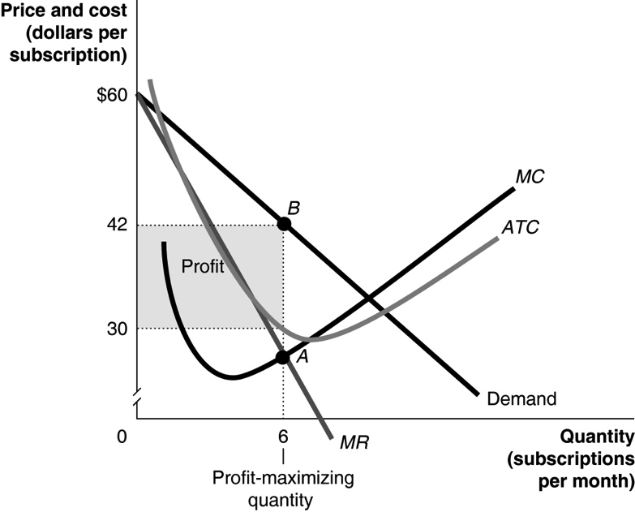
3.4 a.
Price | Quantity  (per week) | Total Revenue | Marginal Revenue | Total Cost | Marginal Cost
$20 | 15,000 | $300,000 | --- | $330,000 | ---
19 | 20,000 | 380,000 | $16 | 365,000 | $7
18 | 25,000 | 450,000 | 14 | 405,000 | 8
17 | 30,000 | 510,000 | 12 | 450,000 | 9
16 | 35,000 | 560,000 | 10 | 500,000 | 10
15 | 40,000 | 600,000 | 8 | 555,000 | 11
b. To maximize profits, Ed should produce where marginal revenue equals marginal cost. So, he should charge $16 per baseball and produce 35,000 baseballs per week. His weekly profits will be $560,000 – $500,000 = $60,000. Note: In the graph, we have rounded the average total cost to $14.28. So, the calculation of total profit would be: ($16.00 − $14.28) × 35,000 = $60,200.

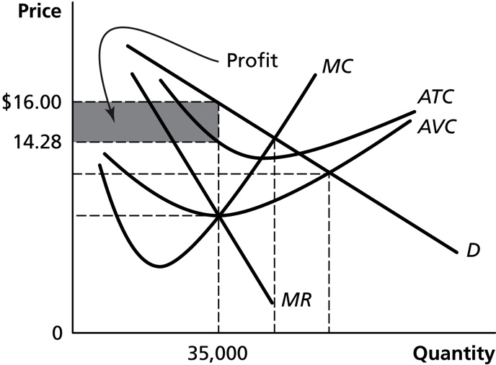
c. Because the tax does not affect his marginal revenue or marginal cost, Ed should not change the price he charges or the quantity he produces. His profits will fall by the amount of the tax, from $60,000 to $10,000.
d. Because the tax does not affect his marginal revenue or marginal cost, Ed should not change the price he charges or the quantity he produces. His profits will fall by the amount of the tax, from a profit of $10,000 (when the tax is $50,000) to a loss of $10,000 (when the tax is $70,000). If these losses continue, however, Ed will exit the market in the long run because firms are unwilling to suffer losses in the long run.
3.5 a. In the short run, Comcast will continue to sell 6 subscriptions at $24 each. Its total revenue = $144, but its total cost is now $110 + $36, so its loss is $2. If this loss continues, in the long run Comcast will exit the market. See table below.
b. The new tax increases the marginal cost by $25 per subscriber and increases the total cost at each price level by ($25 × quantity). With the tax on each subscriber, marginal revenue is never greater than marginal cost, so Comcast would shut down and sell no subscriptions.
P | Q | Total Revenue (TR) | Marginal Revenue  (MR) | Total cost (TC) | Marginal Cost (MC) | Profit | Profit with $25 tax | Profit with $36 tax | TC with $25 per subscriber tax | Profit with $25 per subscriber tax
$27 | 3 | $81 | --- | $56 | --- | $25 | $0 | $−11 | $131 | $−50
26 | 4 | 104 | $23 | 73 | 17 | 31 | 6 | −5 | 173 | −69
25 | 5 | 125 | 21 | 91 | 18 | 34 | 9 | −2 | 216 | −91
24 | 6 | 144 | 19 | 110 | 19 | 34 | 9 | −2 | 260 | −116
23 | 7 | 161 | 17 | 130 | 20 | 31 | 6 | −5 | 305 | −144
22 | 8 | 176 | 15 | 151 | 21 | 25 | 0 | −11 | 351 | −175
3.6 You are likely to suffer a loss because demand for slide rules is so low. If a profit was likely in this market, someone would probably have already entered it. The graph below shows the situation you are likely to be in.
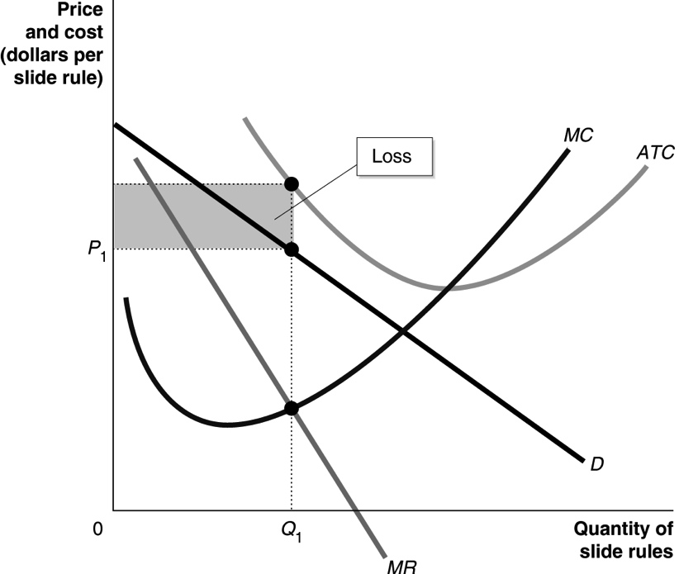
3.7 Here is the definition of the supply curve from Chapter 3: “A curve that shows the relationship between the price of a product and the quantity of the product supplied.” For a firm operating under perfect competition, there is a supply curve because it always equates price to marginal cost. Therefore, there is always just one price for every level of output. Because a monopolist equates marginal revenue to marginal cost, with marginal revenue being less than price, it is possible for there to be different prices for the same level of output. It is also possible to have many different output levels for the same price level. Therefore, a monopolist does not have a supply curve.
3.8 The student’s argument is incorrect. As the graph shows, a reduction in marginal cost will cause a monopolist to reduce his price, produce more, and increase profits.
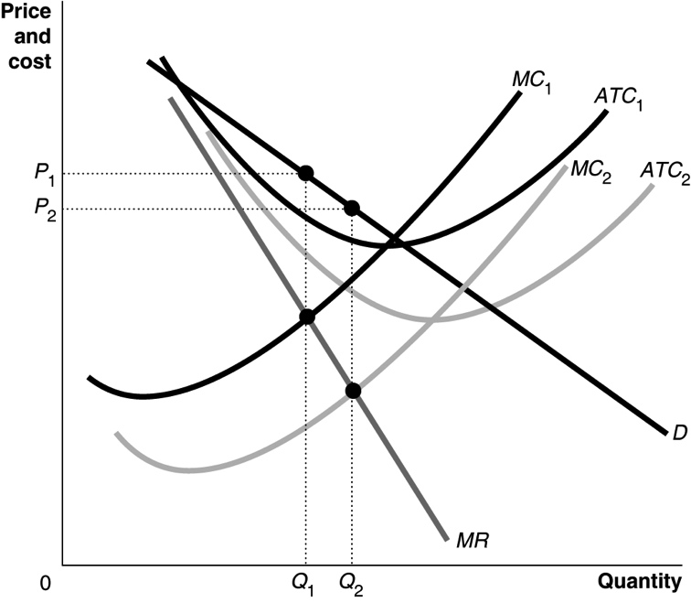
3.9 When a monopoly exists, it doesn’t set the price whimsically; it sets the price so that consumers will buy the quantity at which marginal cost equals marginal revenue, thereby maximizing the firm’s profit. It is doubtful that a company in this situation would charge a price as high as $500 per month because doing so would greatly reduce the quantity demanded and profit would be less than if a lower price were set.
3.10 Profit maximization is not the same thing as revenue maximization. To maximize revenue, the firm would produce up to the point where marginal revenue is zero. Unless marginal cost is zero, this is a larger quantity than the quantity where marginal revenue equals marginal cost. Maximizing production could mean producing the physical maximum possible. This quantity is likely to be far beyond the profit-maximizing level.

15.4 | Does Monopoly Reduce Economic Efficiency?  Learning Objective: Use a graph to illustrate how a monopoly affects economic efficiency.
Review Questions
4.1 If a perfectly competitive industry is monopolized, typically the price will rise and the quantity produced will fall. Consumer surplus will decrease, producer surplus will increase, and there will be a deadweight loss. Figure 15.5 on page 491 of the main text shows this.
4.2 Market power allows a firm to set its price above marginal cost, which creates a deadweight loss. Research suggests that in the United States total deadweight loss from market power is fairly small, perhaps less than 1 percent of GDP.
Problems and Applications
4.3 The less elastic is the demand curve, the greater market power the firm has, the larger is the difference between the marginal benefit (which equals the price) and marginal cost of the last unit produced and, therefore, the greater is the deadweight loss due to the monopoly.
4.4 If the monopoly were more efficient, its marginal costs would decrease—from MC₁ to MC₂ in the figure. As the figure shows, if a monopoly has higher costs (MC₁) because it does not face competition, then the true deadweight loss is increased. The darker shaded area shows the original deadweight loss as it was in Figure 15.5 on page 491 of the text. The lighter shaded area shows the additional deadweight loss from taking into account x-inefficiency—that is, from the firm not producing more efficiently, at quantity Q_{CX}.
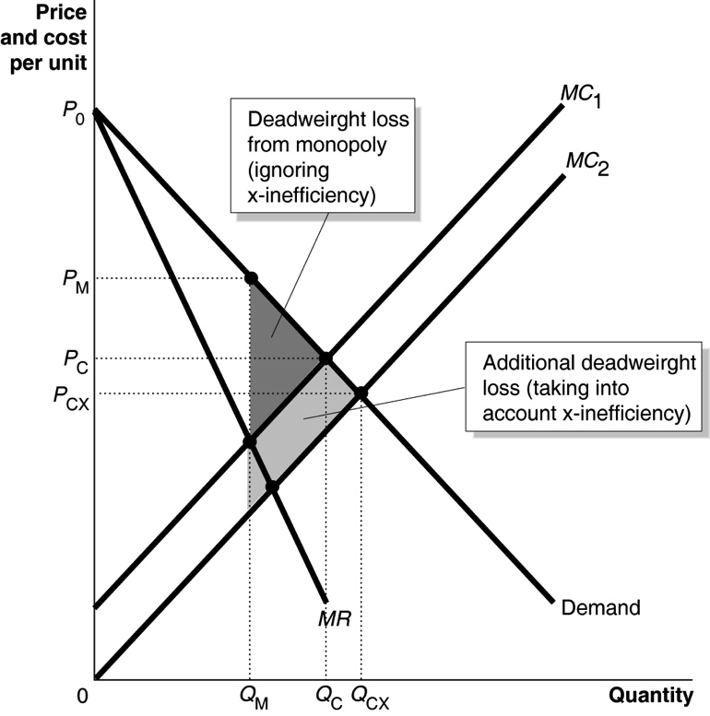
4.5 Charging by the gallon is more likely to achieve allocative efficiency—as long as the price equals the marginal cost. To charge by the gallon, the city has to install a water meter in each firm and home and employ meter readers to gather information on how many gallons have been used. Some cities charge flat monthly fees to avoid this expense.
4.6 If a market is a monopoly, a negative externality in production will not always lead to production beyond the level of economic efficiency. In the following graph, the competitive output is at Q₁, where price, P₁, equals marginal private cost, MC₁. If this market is a monopoly, the profit-maximizing output is at Q₂, where marginal revenue is equal to marginal private cost. With a negative externality in production, the marginal social cost curve is MC₂. The point where price, P₂, is equal to marginal social cost is economically efficient. In this example, the economically efficient quantity, Q₂, is the same as the profit-maximizing quantity. Although the economically efficient quantity and the profit-maximizing quantity are the same on this graph, this will not always be the case.
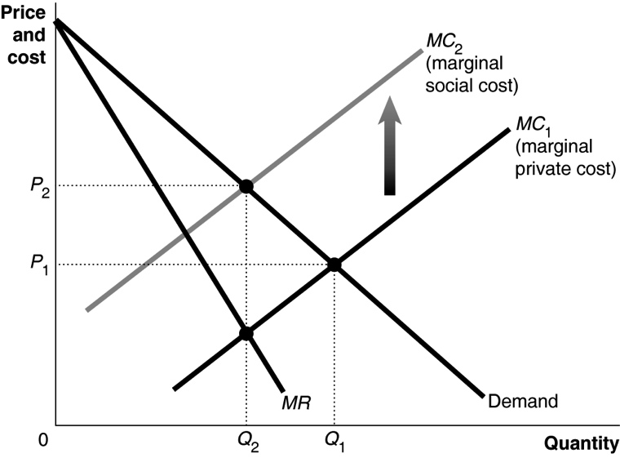
4.7 If increased competition between the two restaurants leads to lower prices, consumer surplus and economic efficiency will increase. It is possible, though, that the average total cost of producing seafood dinners will be higher for two firms than it was for the Fisherman’s Friend operating alone in the market. If this outcome occurs, the Fisherman’s Friend was a natural monopoly, and prices will be higher, while consumer surplus and economic efficiency will decline, following the entry of the second restaurant. In addition, it is possible that with just two firms in the market, they may collude be agreeing to charge the same prices or otherwise not compete.
4.8 a. Jorge will produce at the level of output in which MR = MC, which is 15 caps. At 15 caps, Jorge would charge a price of $20 per cap.
b. Profit is TR – TC. Because TR (P × Q) is $300 and TC (ATC × Q) is $240, Jorge would earn a profit of $60.
c. Allocative efficiency occurs at the level of output at which MB (or P) = MC. So if Jorge produced at the allocatively efficient level of output, he would produce 20 caps.
d. The deadweight loss = ½ ($20 − $10)(20 − 15) = $25.

15.5 | Government Policy toward Monopoly  Learning Objective: Discuss government policies toward monopoly.
Review Questions
5.1 The stated purpose of the antitrust laws is to eliminate collusion and promote competition among firms. The Department of Justice’s Antitrust Division and the Federal Trade Commission enforce these laws.
5.2 A horizontal merger is between firms in the same industry, while a vertical merger combines firms at different stages in the production of a good. Horizontal mergers are more likely to increase the market power of the newly merged firm because these mergers reduce the number of firms competing in the market for a particular good or service.
5.3 Charging a price equal to marginal cost means that output will be at the level at which marginal cost equals marginal benefit (typically represented by price), which is the efficient level of output. However, charging this price would mean that the typical regulated natural monopoly would suffer an economic loss, as this price will be below average cost. If the regulator sets price to equal average cost instead, some efficiency will be lost, but the natural monopoly will stay in business and earn a normal profit.
Problems and Applications
5.4 a. To maximize profit, the monopoly will produce the quantity where marginal revenue equals marginal cost. So, the monopoly will produce 50 units and charge a price of $10.
b. To achieve economic efficiency, the regulatory agency should require the monopoly to charge a price equal to marginal cost, which in this case would be a price of $7. The regulated monopoly will produce 90 units. It will make a profit because price is above average total cost.
5.5 a. To maximize profit, the monopoly will produce the quantity where marginal revenue equals marginal cost. So, the monopoly will produce 20 units and charge a price of $30.
b. The monopoly’s marginal revenue curve is now a flat line at $18, running from the vertical axis to the demand curve, so the monopoly will produce 33 units and charge a price of $18. The quantity demanded at a price of $18 is 40, but the quantity supplied is only 33, so there will be a shortage of 7 units, and some consumers will not be able to buy the product.
5.6 Although these results suggest that economic efficiency may be improved by allowing competition in the liquor industry, it does not mean Pennsylvania should necessarily abolish its system of state stores. Normative analysis is concerned with what should be done, whereas positive analysis is concerned with what is. Some people might argue that the system of state stores restrains alcohol consumption, thereby reducing the incidence of drunk driving and the number of people who become alcoholics. These people would be likely to accept a lower level of economic efficiency in exchange for reduced alcohol consumption. A suggestion that the state should abolish its system of state stores is based on normative analysis, which involves value judgments that can vary among individuals.
5.7 If the price is set equal to average total cost, the firm will earn a normal profit. If a firm knows that it will always be able to charge a price equal to average total cost, it will have no incentive to reduce average costs because it will not be able to earn more than a normal profit. In fact, it might try to inflate its costs in its reports to the regulatory agency.
5.8
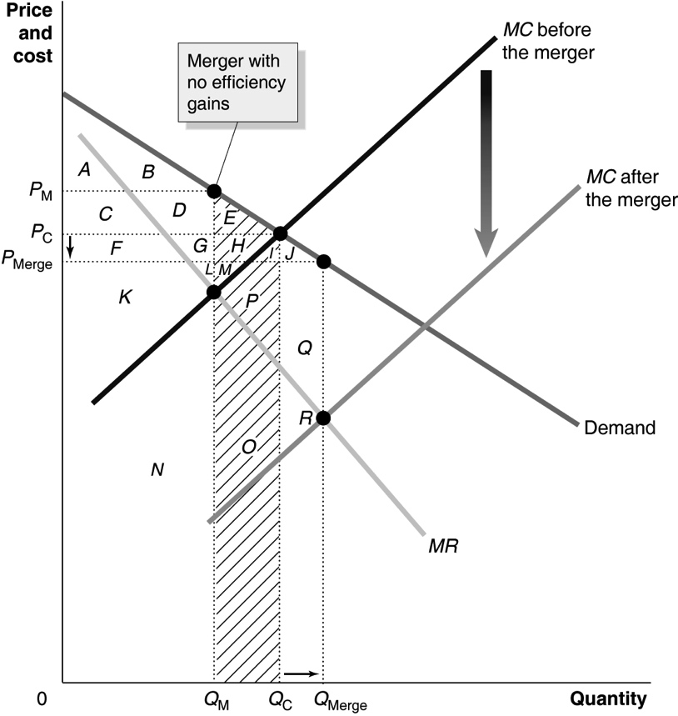
Before the merger, the price was Pc and the quantity was Qc, so consumer surplus equaled the areas A + B + C + D + E, and producer surplus equaled the areas F + G + H + K + L + M. After the merger, price fell to P_{Merge} and quantity rose to Q_{Merge}, so consumer surplus equaled the areas A + B + C + D + E + F + G + H + I + J and producer surplus equaled the areas K + L + M + N + O + P + Q + R.
5.9 a. We need to calculate the Herfindahl-Hirschman Index (HHI). Before the merger: 20 × 5² = 500. After the merger: (16 × 5²) + 20² = 400 + 400 = 800. Because the postmerger HHI is less than 1,000, the merger will not be opposed.
b. HHI before the merger: 5 × 20² = 2,000. After the merger: (3 × 20²) + 40² = 1200 + 1600 = 2,800. Both before and after the merger, the HHI is above 1,800, and the merger will increase the HHI by more than 100 points, so the merger will likely be opposed.
5.10 The Department of Justice press release describes the efficiencies as follows: “the merger likely will result in efficiencies such as cost savings in airport operations, information technology, supply chain economics, and fleet optimization that will benefit consumers. Consumers are also likely to benefit from improved service made possible by combining under single ownership the complementary aspects of the airlines’ networks.” The merger would not substantially lessen competition if the newly merged airline results in lower costs as the result of the elimination of duplicate or unprofitable routes and more efficient flight connections. These lower costs would make the airline more profitable without significantly raising prices or threatening other airlines in the industry.
5.11 The HHI before any merger, assuming five firms in the “other” category, each with a 5 percent share of the market: 25² + 22² + 10² + 9² + 9² + 5(5²) = 1,496, which is considered moderately concentrated. So any merger in this industry that would raise the HHI by more than 100 points will likely be challenged. Because the smallest firms in the “other” category have 5 percent share each, even a merger between two of these firms would likely be challenged.
5.12 a. An agency pricing model contract involves publishers setting the retail price of e-books and Apple keeping 30 percent of the price of each e-book it sold.
b. The Department of Justice would want to keep Apple from signing these agency pricing model contracts because these contracts would allow Apple to sell e-books at a higher price, reducing consumer surplus and economic efficiency. The Department of Justice believed that Apple and the publishers had used the agency pricing model as a way to raise prices of e-books above the levels that Amazon had been charging. The publishers want to continue signing such contracts because the contracts allowed them greater control over the prices of e-books.

