CHAPTER 16 | Pricing Strategy
Solutions to End-of-Chapter Exercises

16.1 | Pricing Strategy, The Law of One Price, and Arbitrage
 | Learning Objective: Define the law of one price and explain the role of arbitrage.

Review Questions
1.1 According to the law of one price, identical products usually sell for the same price everywhere. Arbitrage is the practice of buying a product in one market at a low price and reselling it in another market at a high price.
1.2 When arbitrage can easily occur, the law of one price will hold, but if transactions costs are high, the law of one price needn’t hold. In addition, transportation costs can result in the same product selling for different prices in different locations.
Problems and Applications
1.3 The New York residents are buying goods at a low price in New Jersey, but they are not re-selling them at a higher price in New York. So they are not, strictly speaking, engaged in arbitrage.
1.4 Unless there are big differences in the quality of the retailers in terms of shipping, delivery, or ease of use of their Web sites, these data would seem to contradict the law of one price. We know, though, that Amazon and Wal-Mart have well-known Web sites with good reputations for rapid and dependable delivery. So, we might expect that the other two sites, which are less well-known, would charge less for this Blu-ray disk. These sites hope that their lower prices may attract customers who would otherwise be reluctant to buy from a Web site with which they were unfamiliar. Because a Blu-ray disk being offered for sale from a well-known site such as Amazon or Wal-Mart is not the same as a disk being offered for sale on a much less well-known site, the information in the table does not contradict the law of one price.
1.5 Abner is not exploiting the consumers in Nevada by engaging in arbitrage. Because of his activities, consumers in Nevada can buy apples at a lower price than they would otherwise pay. Because others besides Abner would see the profit potential of engaging in arbitrage, they are likely to begin competing with Abner. This competition will keep Abner from earning economic profits in the long run.
1.6 Valerian might be suspicious of eBay because many of its users buy at a low price to resell at a high price. However, if he were to find an item on eBay that had great value to him and could not be found in Cimiez, he might temper his judgment. Valerian’s worry seems to be that arbitrageurs are making unfairly high profits, but eBay actually helps increase competition, thereby reducing the middleman’s economic profits while increasing consumer surplus.

16.2 | Price Discrimination: Charging Different Prices for the Same Product
 | Learning Objective: Explain how a firm can increase its profits through price discrimination.
Review Questions
2.1 Price discrimination is charging different prices to different customers for the same product when the price differences are not due to differences in cost. A firm can successfully practice price discrimination if it possesses market power, if some consumers have a greater willingness to pay than others, if the firm knows what prices customers are willing to pay, and if the firm can divide up (or segment) the market so that consumers who buy the product at a low price cannot resell it at a high price (in other words, consumers cannot practice arbitrage).
2.2 Because children are charged the lowest admission price, demand for their tickets is the most elastic. Because adults are charged the highest admission price, demand for their tickets is the least elastic. And because admission for seniors and the military is the second highest, demand for their tickets is less elastic than for children but more elastic than for adults.
2.3 Yield management is the use of models of demand and pricing strategies to maximize revenue and profits. One example of yield management is the practice of airlines varying ticket prices based on, for example, the purchase date, season, length of route, day of the week, and time of the flight.
2.4 Perfect price discrimination (also called first-degree price discrimination) is the practice of charging each consumer a price equal to the consumer’s willingness to pay. It is not likely to ever occur in practice because firms cannot know the exact amount most consumers are willing to pay. It is economically efficient because output is increased to the point where marginal cost equals marginal benefit. However, all consumer surplus is converted into producer surplus.
2.5 An example of price discrimination across time is when early buyers, whose price elasticity is lower, are charged more than later buyers—whose price elasticity is higher. This type of price discrimination occurs in the market for hardcover fiction books and in the markets for many consumer electronics products.
Problems and Applications
2.6 A “road warrior” is a person who travels extensively on business. These are people are often unable to make travel plans more than a few days in advance and typically do not want to stay more than a day or two in the city where they are traveling. A company may put restrictions on a service that make that service less desirable to some of its customers if those customers do not have any viable alternative to using the service, and if the restrictions increase the profitability of the company. In this case, airlines are using the restrictions to separate business travelers—who are willing to pay higher ticket prices—from leisure travelers—who are less willing to pay higher ticket prices.
2.7 The airlines offer their lowest prices so far in advance of flights because they know that those who can plan so far in advance are more sensitive to price. Those travelers who wait until closer to the date are typically not as flexible with their travel plans, so they are not as sensitive to price and will pay more. The airlines might provide further discounting if they discover they have empty seats just prior to the flight.
2.8 Truth serum would be very useful for one of the requirements to price discriminate: determining different customers’ willingness to pay. However, the airlines would still need to keep the people who buy at low prices from reselling their tickets at high prices.
2.9 The New York Times is charging consumers who are willing—or claim to be willing—to cancel their subscriptions lower prices than consumers are who don’t make this claim (or who don’t realize that making the claim might result in a 50 percent reduction in their subscription price). Assuming that the elasticity of demand for consumers who call up to threaten to cancel is greater than the elasticity of those who don’t call up, the Times is engaging in price discrimination.
2.10 a. This policy is not pure price discrimination because there are differences in costs. However, the differences in prices may have been greater than the differences in costs, so there might have been some price discrimination involved.
b. Most economists would argue that for a competitive industry like dry cleaning, in the long run price will equal the average cost of providing a service, and government intervention, which is often costly to enforce, will not be necessary. However, some people could support this law on normative grounds, especially if they were likely to benefit from it personally.
2.11 a. The graph shows that in Market 1, marginal revenue equals marginal cost at a quantity of 25. Therefore, a price of $7 should be charged to maximize profits.
b. The graph shows that in Market 2, marginal revenue equals marginal cost at a quantity of 45. Therefore, a price of $11 should be charged to maximize profits.
2.12 Price discrimination can be effective for firms when the price elasticity of demand for their product varies from one group of customers to another. Apple cuts prices more to students for its laptop because students have a more elastic demand than businesspeople do.
2.13 From the description, it does not appear that Apple is engaging in price discrimination because it is offering a different iMac, a lower-end model with presumably a different cost of production, for a lower price to certain schools and universities. Apple may not offer these computers to the general public because they are likely less price-sensitive and will pay more for a slightly different model.
2.14 Initially we are assuming that universities charge a different price to each student, which is an example of perfect price discrimination. As the chapter explains, the demand curve is the marginal revenue curve for a perfect price discriminator. A university acting as a perfect discriminator would behave as shown in the following graph:
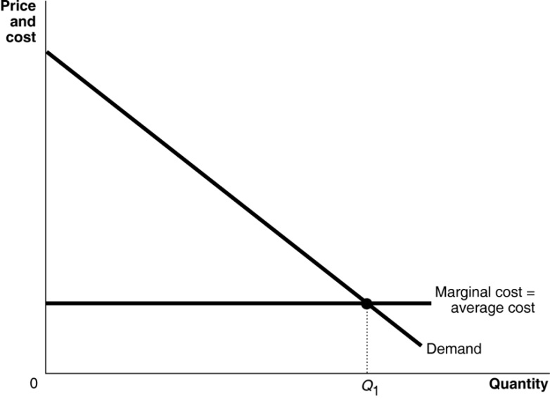
In this scenario, the marginal revenue curve is the demand curve, so the profit-maximizing quantity is Q₁. You should also notice that this quantity achieves allocative efficiency because marginal benefit equals marginal cost at this quantity.
The figure below shows the consequences of forcing the universities to charge the same price (P₂) to each consumer. In this scenario, the number of people admitted into college declines to Q₂ from Q₁. Students who were paying more than P₂ before the change in policy gain because they now pay less to attend college. However, fewer students will be attending college, and some of those who do will be paying a higher price. Because the new equilibrium quantity is below the allocatively efficient quantity, there is now a deadweight loss. The areas representing profit, consumer surplus, and deadweight loss are represented in Figure 16.3 on page 516 in the textbook.
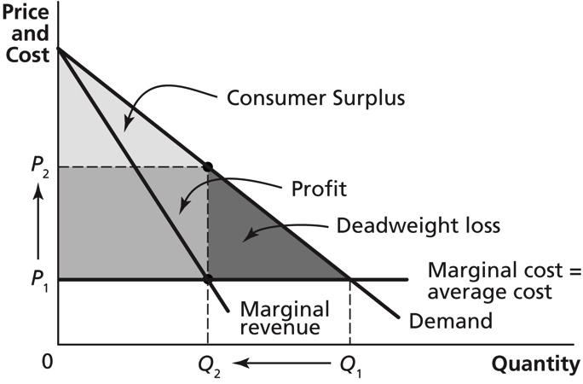
2.15 a. Disney is assuming the demand for tickets by Florida residents is relatively elastic. Because residents of Florida can travel to Orlando more easily and more frequently than residents of other states, Florida residents may have other nearby options for entertainment.
b. Disney could prevent Florida residents from selling their discounted tickets to non-Florida residents for a higher price by making sure that Florida residents prove their residency (for instance, by showing a driver’s license) when buying the discounted tickets and by making someone attempting to enter the park using a discounted ticket present a Florida driver’s license.
c. Again, firms will charge a lower price to a group whose demand is more elastic. So if Disney tickets are offered at a discount to students from Florida universities, their demand for tickets must be relatively elastic. And because college students typically have limited budgets, Florida university students are likely offered a larger discount than are other residents of Florida.
2.16 a. Yes, even if shoppers who use a loyalty card all get the same discount, the use of loyalty cards by the grocer is a form of price discrimination. Shoppers who go to the effort of signing up for and using loyalty cards are likely to be more responsive to price discounts than are shoppers who do not go to this trouble. So charging shoppers who use loyalty cards lower prices on some products is a form of price discrimination.
b. By tracking the items that consumers buy, firms compile data they can use to adjust prices based specifically on what consumers purchase. If a shopper regularly buys a particular product, the firm might determine that the shopper is loyal to that product and would not be as sensitive to price. As a result, the firm may not offer a discount on that product.
2.1 a. The company is able to use price discrimination due to the differences in price elasticity of demand for underpads used by people and by dogs, and because the company disguises the fact that the pads—although sold in different packages—are identical.
b. If the demand for underpads used by dogs is more inelastic than the demand for underpads used by people, the company can charge a higher price for underpads used by dogs. It may be that the firm faces fewer competitors in the market for underpads used by dogs than in the market for underpads used by people.
2.18 Yes, coupons are a form of price discrimination. People who are willing to take the time to clip coupons have a higher price elasticity of demand than people who are not willing to clip coupons. Coupons are a way for firms to cut the price paid by consumers with a higher price elasticity without having to cut the price for everyone else.
2.19 a. To maximize profit, Yasiel should produce where MR = MC. Because MC = $5, we need to find the level of output in which MR = $5. Because MR = the change in TR divided by the change in Q, we can calculate that MR = $5 for the third unit of output. So Yasiel should produce 3 pizzas and charge a price of $15 per pizza. Profit = TR – TC. Because TR for 3 pizzas is $45 and the TC of 3 pizzas $15, Yasiel would earn of a profit of $30.
b. If Yasiel is able to engage in perfect price discrimination, his TR for 3 units would be $15 + $20 + $25 = $60. The marginal revenue of the third unit would be $60 − $45 = $15.
c. Profits are maximized where MR = MC. MR = MC = $5 at the fifth unit of output, so Yasiel should produce 5 units of output. If 5 units are produced, profit (TR – TC) would be $75 − $25 = $50.
d. In the graph on the left below, the areas of producer surplus, consumer surplus, and deadweight loss are noted. In the graph on the right, in which Yasiel practices perfect price discrimination, the consumer surplus and deadweight loss are converted into producer surplus (profit).
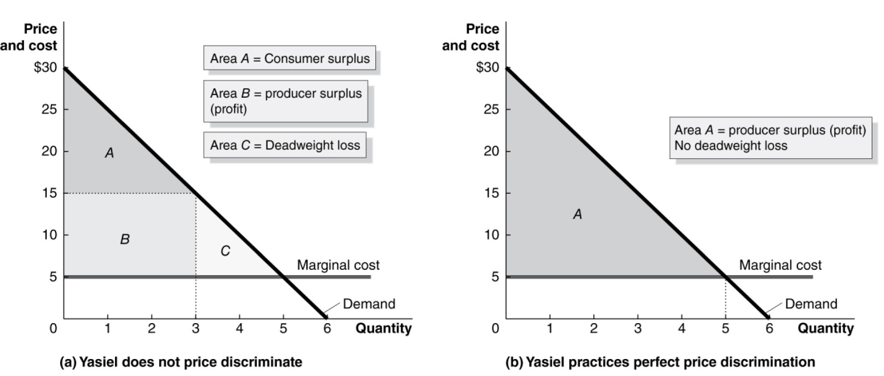

16.3 | Other Pricing Strategies  Learning Objective: Explain how some firms increase their profits by using odd pricing, cost-plus pricing, and two-part tariffs.
Review Questions
3.1 Odd pricing is the practice of charging prices that aren’t round numbers, especially prices ending in 9 or 5 rather than 0. One important reason for odd pricing is to give buyers the illusion that they are paying significantly less: $99.99 seems significantly less than $100 to some consumers.
3.2 Cost-plus pricing involves setting prices by adding a percentage markup to average cost. It is inconsistent with profit maximization in most cases—unless marginal cost and average cost are roughly equal or the firm has trouble estimating its demand curve. Firms use smaller markups for products with more elastic demand and larger markups for products with less elastic demand.
3.3 A two-part tariff exists when consumers pay one price for the right to buy a good and another price for each unit of the good itself. Examples include cell phone companies that charge both a monthly fee and a per-minute or per-text charge, and country clubs that have annual membership fees and charge members each time they use the tennis court or golf course.
Problems and Applications
3.4 If this explanation of odd pricing is correct, you would expect to see it used more often among people who are not comfortable with math or less well educated. Banning the practice probably wouldn’t make much difference. Consumers might make slightly wiser choices, but they would have to pay slightly more and a few would lose the feeling of having made a good deal. In any case, in competitive markets, firms do not make economic profits in the long run.
3.5 It is likely that McDonald’s and Burger King believe that the elasticity of demand for French fries and for sodas is lower than the elasticity of demand for hamburgers. The less elastic the demand for a product is, the less substitution there will be away from the product in response to an increase in price.
3.6 The huge markup on the price of wine is likely due to the demand for wine by restaurant customers being relatively inelastic relative to the demand for food. Consumers can often compare the prices restaurants charge for food by looking at menus posted online. Few restaurants post their wine prices online. In addition, while many consumers have at least a rough idea of the prices of comparable meals at other restaurants, they may have less information on the prices of similar bottles of wine at other restaurants.
3.7 The firm was using the cost-plus method of pricing. Because the firm produced so many products, it may have been profitable to use this pricing method instead of investing the resources needed to estimate demand and marginal cost in each separate market. In general, though, the cost-plus price is usually not the profit-maximizing price.
3.8 We should not expect a publishing company to use cost-plus pricing for all its books. We can see evidence that cost-plus pricing is not always used by looking at prices of the same book in different markets (for example, the United States and Europe), or by noting that best sellers usually sell for lower prices, or that the relative prices of some books change over time.
3.9 a. This is a variation of the Disney World, two-part tariff problem. The team will make more profit by keeping the season ticket prices low.
b. After the first year, the team no longer collects revenue from seat licenses, so it would have an incentive to raise the price of season tickets.
c. If it still has some seat licenses unsold, then it will not raise season tickets as much as it would if it sold them all the first year.
3.10 This is a variation of the Disney World, two-part tariff problem. The railroad companies would maximize their combined profit from selling land and shipping freight by keeping freight prices lower than they would if they did not also have land to sell. The railroad companies were aware that farmers would be able to make greater profits—and, therefore, would be willing to pay more for land—if freight charges were low.
3.11 When Disney charged a low price for admission while requiring people to purchase tickets to go on the rides, its overall profit was lower because of the deadweight loss created by the monopoly price. By acting as it would in a perfectly competitive market and charging a price equal to marginal cost ($0) for the rides, Disney is able to increase its overall consumer surplus and charge a higher price for admission tickets, thereby converting more consumer surplus to producer surplus and increasing its overall profit.
3.12 The town could charge a fixed fee for garbage collection plus an additional fee per garbage can.

